Selective Service Verification

The purpose of the Selective Service form is to comply with the Military Selective Service Act, 50 App. U.S.C. 451, et seq, requiring all males aged 18 through 26 to register with the Selective Service Administration. In support of this Federal regulation, the State of Montana prohibits a state agency or post-secondary institution from employing any individual who has failed to register. In support of this Federal regulation, the State of Montana prohibits a state agency or post-secondary institution from employing any individual who has failed to register.

There are 3 ways to verify Selective Service:
- Verify that you have seen the Selective Service Registration card
- Verify that you have seen the Selective Service acknowledgment letter
- Verify the registration online

To verify the registration online:
- Go to: www.sss.gov
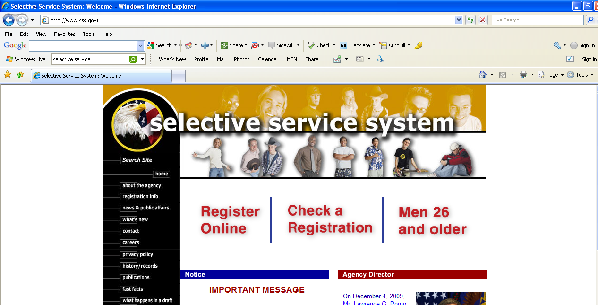

- Click on “Check a Registration”

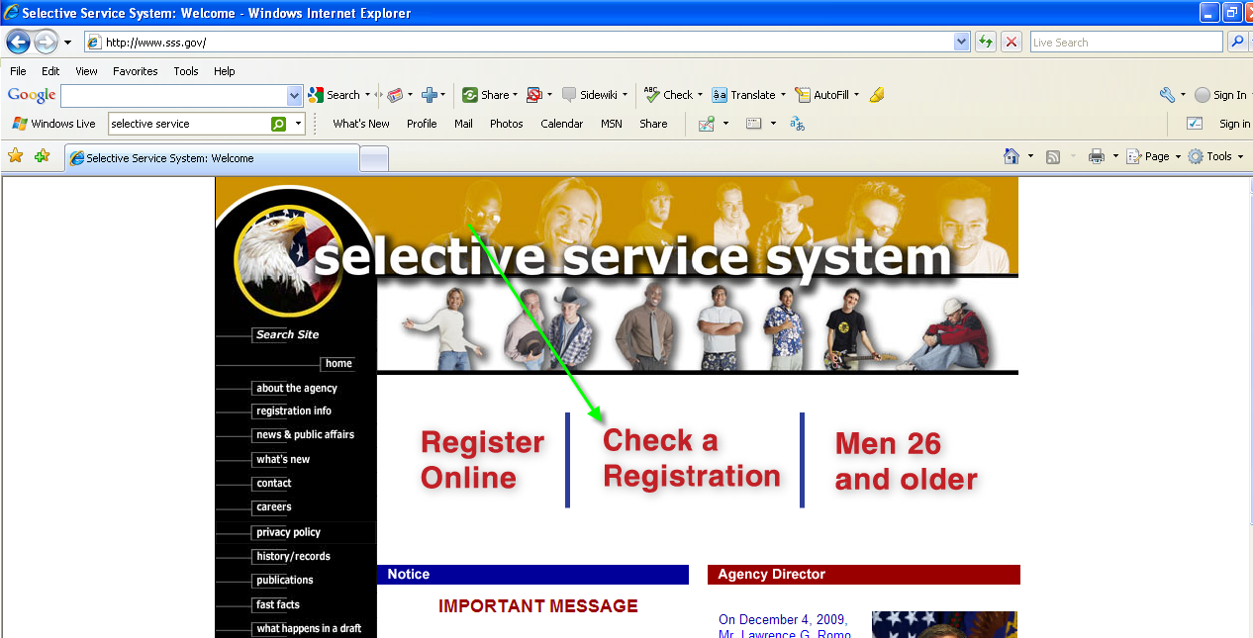

- Enter the employee’s:
  - Last Name
  - Social Security Number
  - Date of Birth

HINT: The SS # and DOB are on the I9
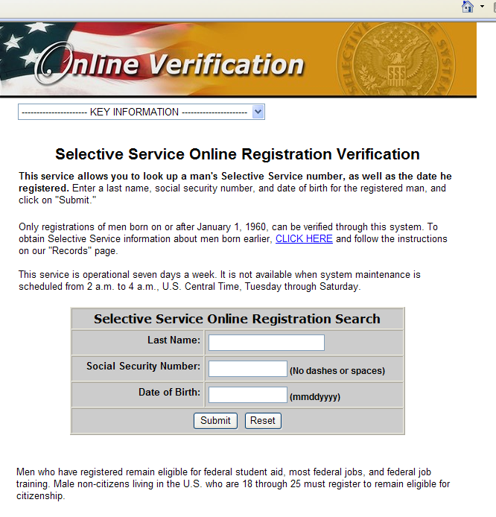

- Click on the “Submit” button

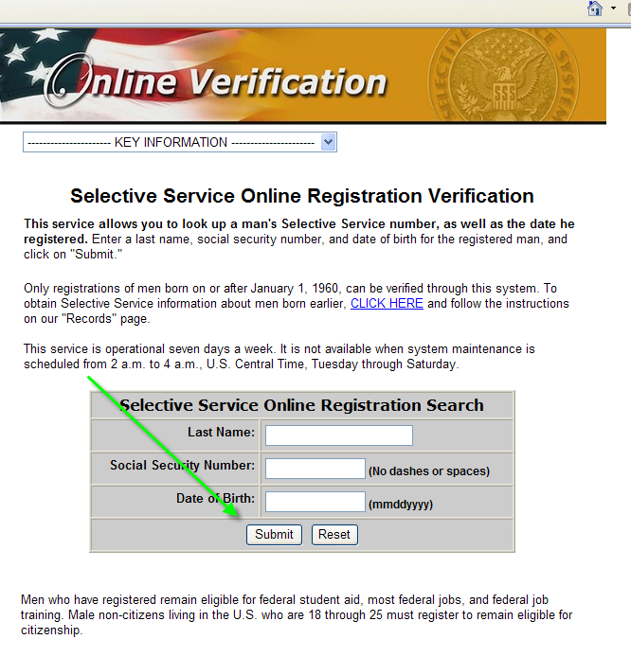

- If they are verified you will get a message like this:
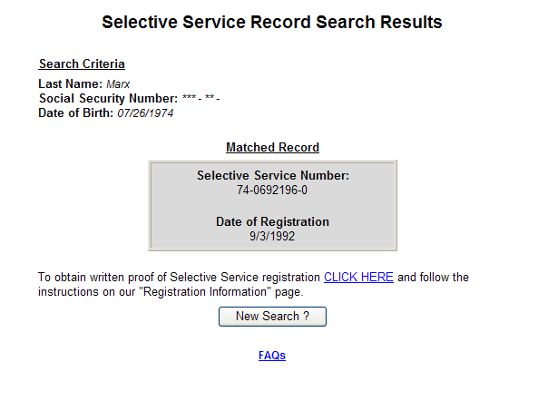

- Sign the bottom of the form and turn into Auxiliary Services Payroll

- If they are not registered you will get a message like this:
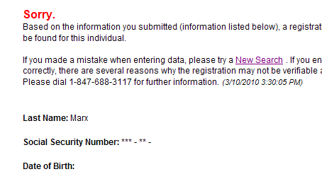

- Make note on the form and send to Auxiliary Services Payroll
- The individual will receive a letter stating that they have 31 days to register and show proof
- If they do not register and show proof by the deadline they will be terminated from their position

Frequently Asked Questions
