Early Career Faculty Mentee Co-Mentor

Co-Mentor Co-Mentor

Plan should be updated annually or when significant changes are made.

Please consider your department’s role and scope documents as you create your development plan and answer these questions.

SCHOLARSHIP AND TEACHING AREAS
Please describe your scholarship area and the questions you are asking or needs that you are trying to address. Also share why it is important and what impact it will have.

Please describe the types of courses that you teach (lecture, studio, lab etc) with the typical number of students.

Please describe the types of service/outreach that you are or would like to be involved in.

SHORT-TERM “SMARTIE” Goals

Identify 3 SMARTI career goals for the next 6-12 months (SMARTI goals are Specific, Measurable, Achievable, Relevant, Time-Based, Inclusive and Equitable).

GOAL 1:

Strategies:

Timeline:

GOAL 2:

Strategies:

Timeline:

GOAL 3:

Strategies:

Timeline:

Identify team members who will help you meet your short-term goals (e.g., other mentors, scientific/creative mentor(s), colleagues, staff):

What additional resources would help you meet your goals? (e.g., students, post-doc, statistical consulting, budget planning or spending guidance, course buyouts, etc.)

What activities are you involved in that will NOT help you achieve your short-term research goals? In other words, what are things you wish you could say “no” to but can’t or won’t? (e.g., excess service commitments, heavy teaching load, conference travel, etc.)

CAREER GOALS

Tenure status/timeline:

What are your medium-term research career goals (next 5 years) and what steps do you need to accomplish to meet those goals?

What are your long-term research career goals? (> 5 years)

SELF-ASSESSMENT
Consider discipline-specific conceptual knowledge, professional/research skills, communication, professionalism, leadership and management, teaching, etc.

Evaluate your skills and abilities in the following areas where:
5 = Highly proficient
1 = Needs improvement

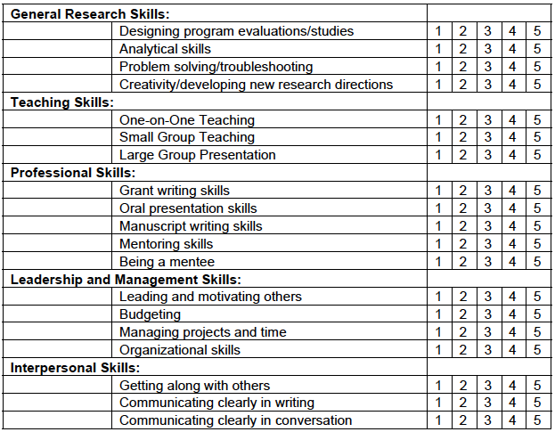

Areas in which I am confident (e.g., research design, time management, writing, etc.):

Areas in which I am challenged (e.g., delegation, managing RAs, budgets, spending, etc.):

CURRENT ACTIVITIES / RESEARCH OUTPUT PLAN

Manuscripts/Books recently accepted/submitted/in progress/planned (*indicates mentored students):

Other manuscript goals or related mentoring needs:

Grant proposals recently submitted/in progress/planned:

Major grant proposal timeline (if this level of funding isn’t applicable to your field, please explain):

Other grant proposal goals or related mentoring needs:

Presentations/Performances/Installations planned:

Other presentation/dissemination goals or related mentoring needs:

Visibility Actions planned (attending Provost’s Lecture, participating in professional organization activities, joining a writing group):

Other visibility goals or related mentoring needs:

Mentorship Environment
Please describe any final goals/needs for your mentoring over the next year:

Please describe any scheduling obstacles (e.g., major grant deadline, extended travel, maternity/paternity leave, etc.) that may affect the ability of mentor or early career faculty to meet regularly over the next year:

Please list “action items” for both mentor and early career faculty following the initial preparation of this plan. Update it regularly.

The Individual Development Plan for Early Career Faculty was developed based on:
- IDP from the University of Montana
- IDP from the University of California – San Francisco

