[SCHOOL DISTRICT NAME]

BEEF TO SCHOOL

REQUEST FOR PROPOSALS
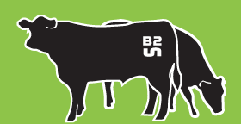
Proposals Due [DATE]
For complete submission information, see Section V: Submission Checklist.
All inquiries for information about this document should be directed to:
[Name, Title, Contact Information]
A Question and Answer Informational [Conference Call or Meeting] will take place on [Date] at [Time]. [Insert location or call-in information, and whether the informational call/meeting is mandatory or just encouraged.]
In accordance with Federal civil rights law and U.S. Department of Agriculture (USDA) civil rights regulations and policies, the USDA, its Agencies, offices, and employees, and institutions participating in or administering USDA programs are prohibited from discriminating based on race, color, national origin, sex, religious creed, disability, age, political beliefs, or reprisal or retaliation for prior civil rights activity in any program or activity conducted or funded by USDA.

Persons with disabilities who require alternative means of communication for program information (e.g. Braille, large print, audiotape, American Sign Language, etc.), should contact the Agency (State or local) where they applied for benefits. Individuals who are deaf, hard of hearing or have speech disabilities may contact USDA through the Federal Relay Service at (800) 877-8339. Additionally, program information may be made available in languages other than English.

To file a program complaint of discrimination, complete the USDA Program Discrimination Complaint Form, (AD-3027) found online at: http://www.ascr.usda.gov/complaint_filing_cust.html, and at any USDA office, or write a letter addressed to USDA and provide in the letter all of the information requested in the form. To request a copy of the complaint form, call (866) 632-9992. Submit your completed form or letter to USDA by:

(1) mail: U.S. Department of Agriculture
Office of the Assistant Secretary for Civil Rights
1400 Independence Avenue, SW
Washington, D.C. 20250-9410;
(2) fax: (202) 690-7442; or
(3) email: program.intake@usda.gov.

This institution is an equal opportunity provider.
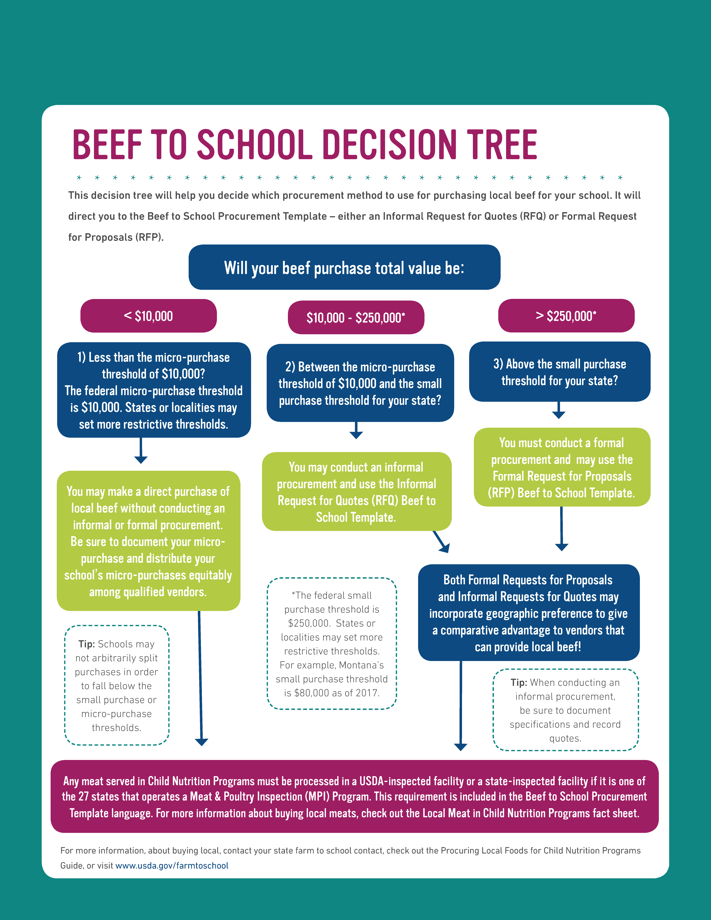
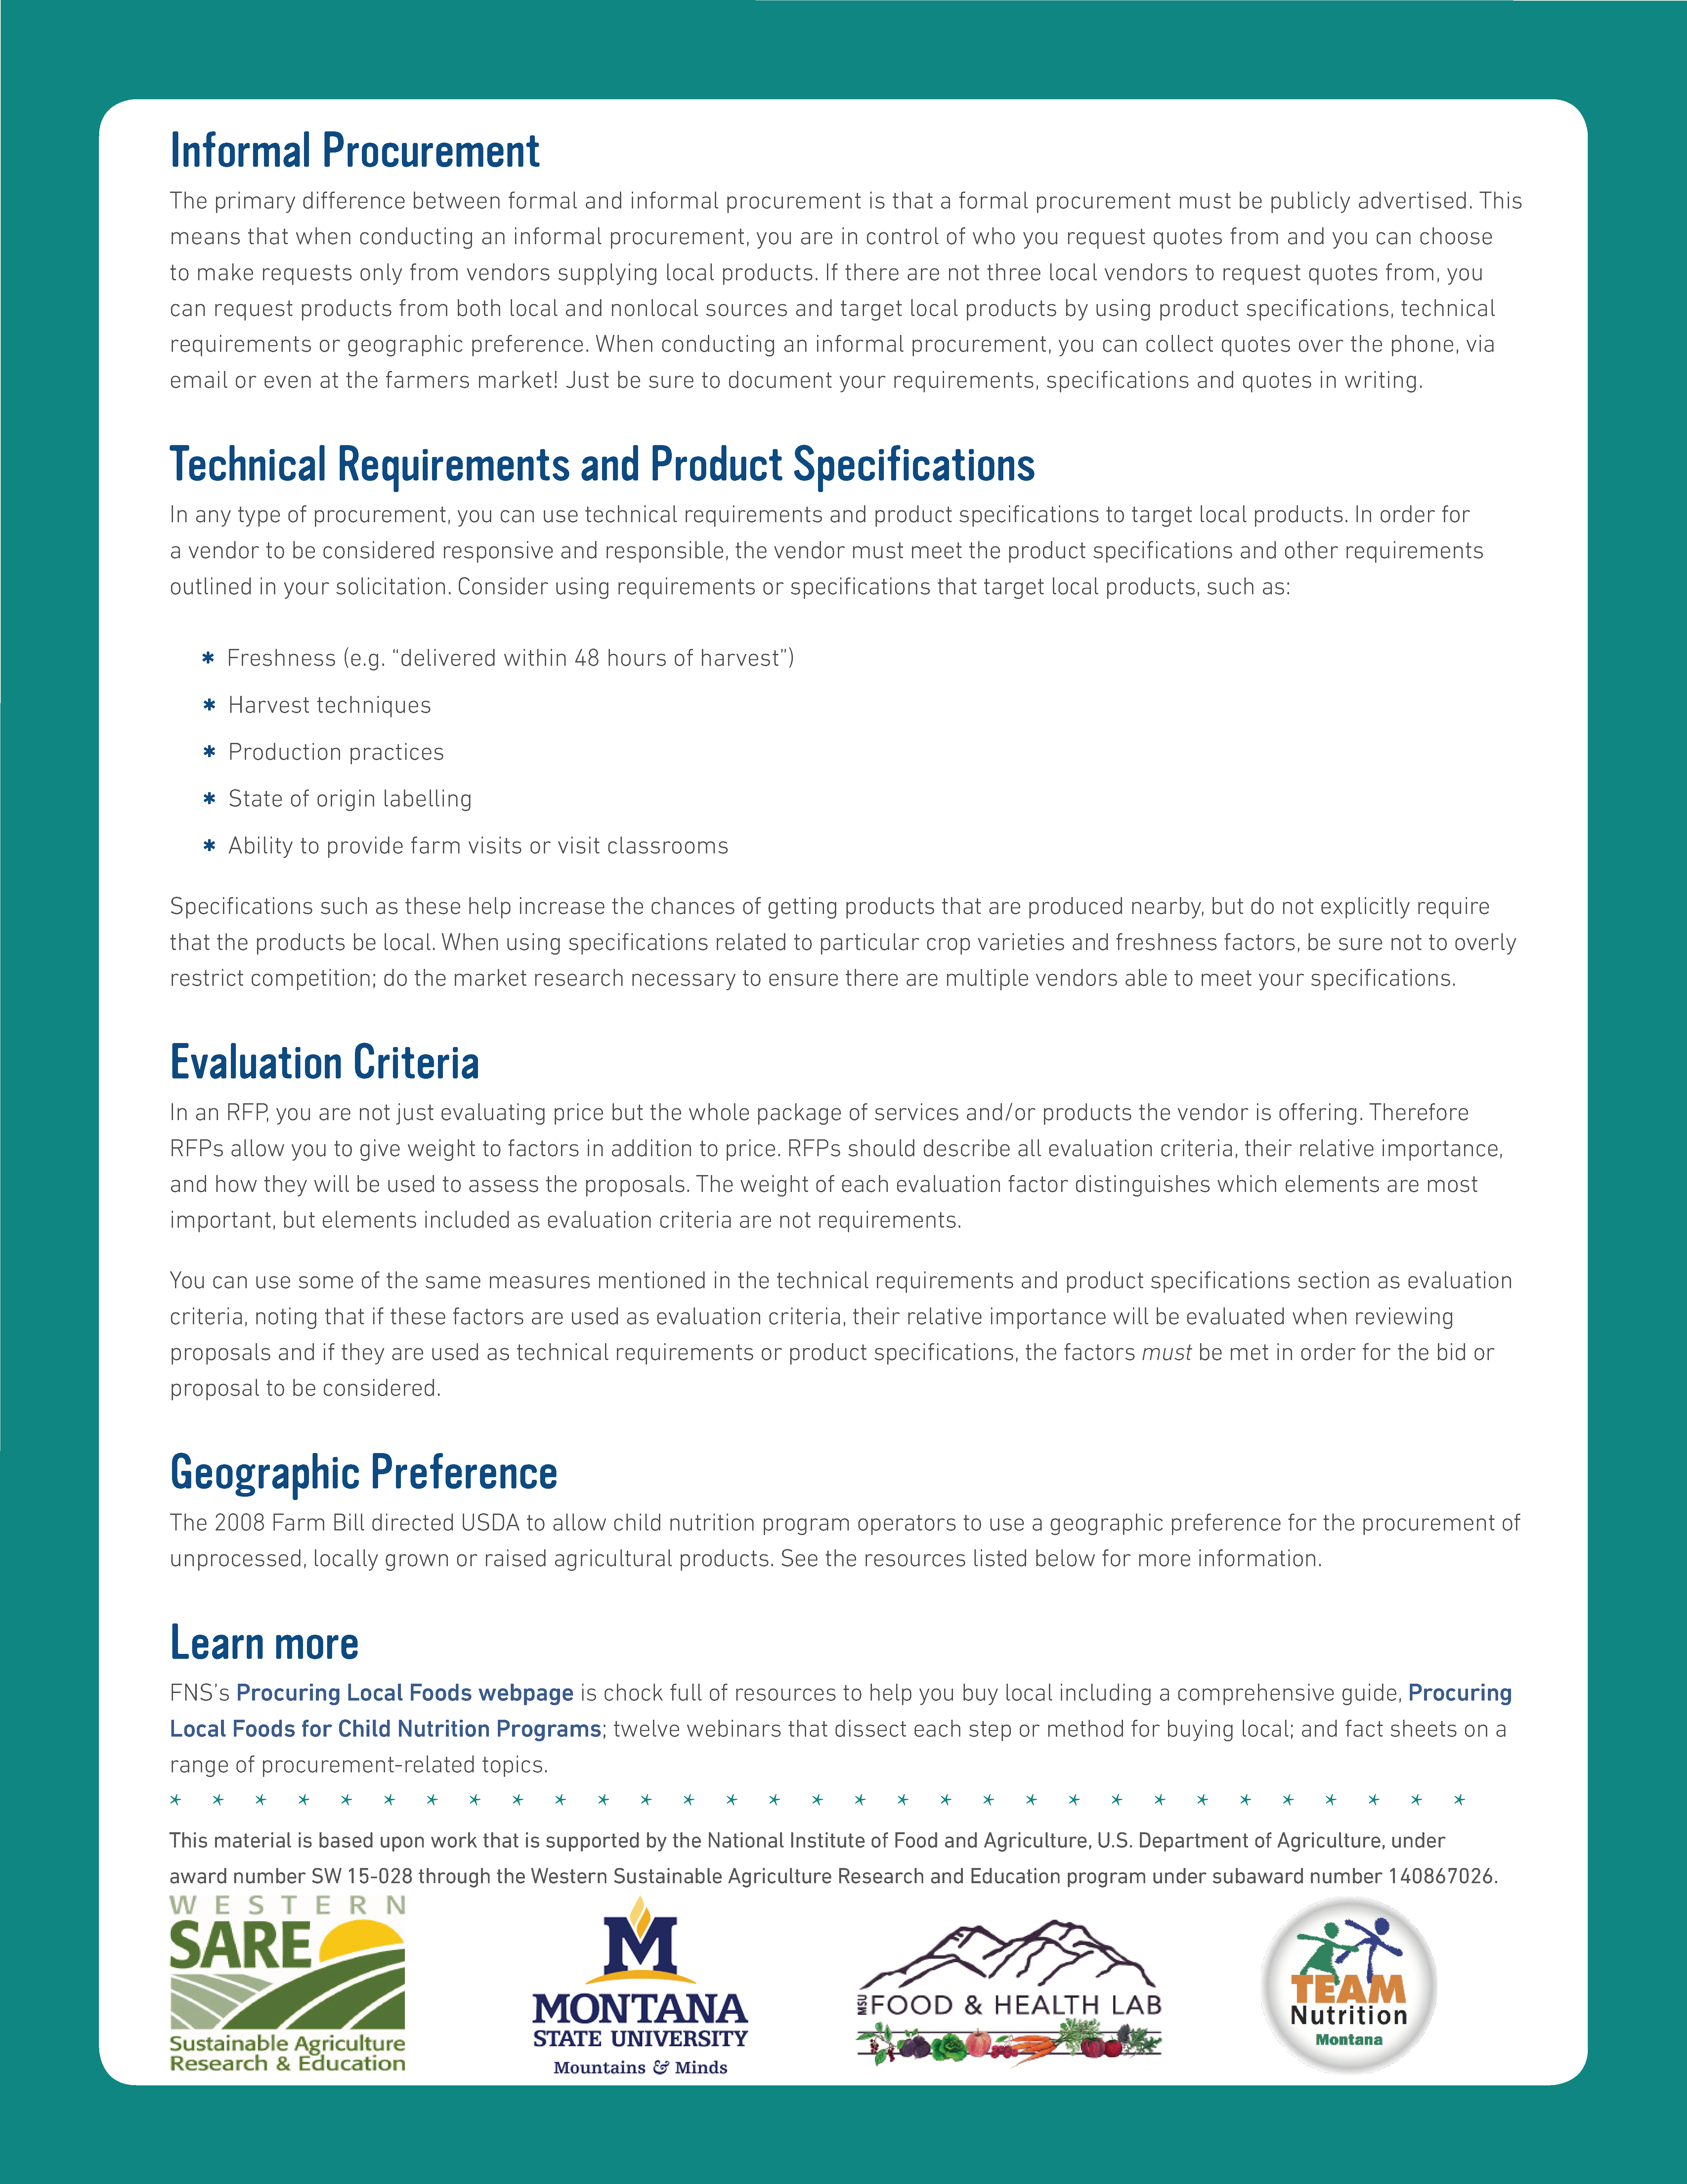

INSTRUCTIONS
This document has been created as a template to help you create a Request for Proposal (RFP) using the formal procurement procedure to purchase local beef at your school.
STEP 1: Review the decision tree above to confirm that the formal procurement method is the correct method for the beef purchase(s) your school plans to make.
STEP 2: Conduct market research. Get to know the beef market in order to create an RFP that is reasonable and encourages competition. For example, knowing when beef is available and how far in advance contracts must be secured can ensure adequate supply. This information can inform the timeline of your RFP process. Making independent estimates before receiving bids or proposals can satisfy the requirement to conduct a cost or price analysis alongside formal procurements.
STEP 2: Review the RFP template below and edit the product specifications and vendor requirements to meet your school’s needs. The formatted [red italicized bracketed text] is used for instructions or sample language that your school district may want to consider. Edit, re-format or delete the red bracketed text and this instruction page before disseminating this RFP. There should be no red bracketed text remaining on your school’s personalized RFP when it is complete and ready to distribute! Delete this instruction page and the decision tree prior to sending your RFP.
STEP 3: Review the RFP carefully and be sure that it is clear, meets your needs, follows your school purchasing procedures, and meets any state and/or local requirements. You may want to check with your legal counsel or procurement expert. Thoroughly review the RFP, Submission Checklist, Vendor Response Form, and Evaluation Criteria to ensure that information is reflected consistently throughout each of these components. If you need assistance, talk with your state agency Child Nutrition Programs contact and/or use this map to find a farm to school point of contact in your state: https://www.fns.usda.gov/farmtoschool/farm-school-contacts.
STEP 4: Publically advertise the RFP using channels that qualified vendors are familiar with, such as the school district’s website. The RFP may also be emailed directly to specific vendors. Conducting a question and answer informational call or meeting is encouraged. Publicize any clarifications or answers provided to vendors so that all vendors have access to the same information.
STEP 5: Evaluate vendor proposals according to the evaluation criteria described in the RFP and select a vendor. Select and notify the vendor(s) that provide(s) the best proposal(s) while meeting all the product specifications and/or vendor requirements. Proposals that do not meet the vendor requirements and/or product specifications may not be considered.
STEP 6: Establish a contract and begin buying local beef! Follow your district’s procedures for translating this RFP into a contract or contracts. It doesn’t stop there - be sure to keep in good communication with the selected vendor and make sure they follow through on the expectations of the contract. Be sure to maintain records sufficient to detail the history of the procurement (the solicitation, responses, selection processes, invoices, etc.)

TABLE OF CONTENTS
INSTRUCTIONS 4
TABLE OF CONTENTS 5
INTRODUCTION 6
GENERAL DESCRIPTION OF GOODS & SERVICES 6
A) Product Specifications 6
B) Additional Specifications 7
VENDOR REQUIREMENTS 7
A) Ordering and Invoicing 7
B) Delivery Requirements 7
C) Additional Vendor Requirements 8
EVALUATION CRITERIA 8
A) Geographic Preference 8
B) Evaluation Criteria 9
TERMS AND CONDITIONS 9
A) Performance Period 9
B) Financial Terms & Conditions 10
C) Buy American Provision 10
D) Contract Modification 10
E) Termination for Convenience 10
F) Termination for Cause 10
SUBMISSION CHECKLIST 11
VENDOR RESPONSE FORM 11
Part 1. General Information 12
Part 1. Ranch(es) 13
Part 2. Beef Processing 14
Part 3. Beef Delivery 15
Part 4. Pricing 15
Part 5. Assurances 16

INTRODUCTION
[Name of School District] (the District) is located in [town, county]. The District has [X#] of school sites and [X#] students. The District’s school nutrition program serves [X#] of lunches per day, as well as [X# of snacks, suppers, breakfast, etc.] [Here you may add any relevant information about the school district, grade levels served, key initiatives, key contact people, etc.]
The District seeks to serve locally-grown and locally-raised food to its students as part of its farm to school program. [Insert more about your farm to school program. Do you have any local food goals? Why is farm to school important to your district?]
The District is accepting proposals from vendors that can provide beef to be served in the District’s school nutrition program. Successful proposals will result in contracts for the [school year or other time frame.]
For the purposes of this solicitation, the District defines locally grown and/or raised as [describe your definition of local as it pertains to beef. Is your definition a certain number miles from your district, within a county, the state, a certain region? Does your district have any commitments to supporting local, minority-owned and/or women-owned businesses?]
A geographic preference will be applied during scoring of proposals: local vendors will receive a comparative advantage compared to non-local vendors that submit proposals. “Local” refers to where the cattle are raised (not processed). This geographic preference is described in more detail in Section IV: Evaluation Criteria.

GENERAL DESCRIPTION OF GOODS & SERVICES

A) Product Specifications
The District seeks the following products:
[Consider which product(s) you need and what details are necessary to convey to vendors exactly what you are looking for without being overly restrictive. Describe which product(s) you need, how they should be packaged, and how and when they should be delivered. If you are flexible on certain specifications, then list acceptable options or keep the description general enough to allow flexibility. Proposals that do not meet the product specifications in this RFP cannot be considered.]
Product/Cut of Beef (see Appendix for examples) | Description | Pack Size | Quantity Per Delivery | Delivery Frequency
[Example: Bulk ground beef] | [80/20 or leaner, frozen] | [10# cases] | [100 lbs] | [Once per month]
The District may award contracts for each product described above to multiple vendors, or may award one contract to one vendor for all desired products at the sole discretion of the District. The District reserves the right to award contract(s) for any, some, none or all of the products above.

B) Additional Specifications
All beef must be processed in a USDA [or state inspected facility]. [Note: state inspection is only applicable in the 27 states that operate a Meat and Poultry Inspection (MPI) Program. To see if your state operates an MPI program, visit https://www.fsis.usda.gov/wps/portal/fsis/topics/inspection/state-inspection-programs/state-inspection-and-cooperative-agreements/states-operating-their-own-mpi-programs.] A seal and/or proof of inspection must be provided as part of a response to this request (see Vendor Response Form). Packaging should be clean with no signs of damage or adulteration.
[Here you can add or clarify additional specifications or preferences. You cannot use “local” as a specification, or require a certain brand. Examples you may use, as long as they do not severely limit competition, include:
- Any packaging requirements or flexibility with packaging material or sizing
- Quality/Grade such as “Grade A”
- The school will accept culled dairy cows or just beef cattle
- The school’s policy about hormones/sub-therapeutic antibiotics
- The school accepts beef from cattle that has been fed grains, grass, or mixed feed
- Must be able to trace each case back to ranch of origin
- Minimum shelf life upon delivery of X days (e.g., 3 days) for fresh product or X months (e.g., 3 months) for frozen product.]
The District has the right to refuse products upon delivery that do not meet the quality standards and specifications described above. In the case of a delivery of unacceptable product, the District will contact the vendor immediately to remedy the situation. This may require a product replacement, substitution or refund. [Add to or edit this description to reflect your school district’s return or refusal of product policy, keeping in mind that flexibility may allow more vendors to participate.]

VENDOR REQUIREMENTS

A) Ordering and Invoicing
The District will provide anticipated usage estimates to the vendor in order to assist with supply accuracy on a [Monthly/quarterly/annual] basis. The District will place orders [Approximately how far in advance?] via [Phone? Email? Either? Other method?] every [#] weeks [or days, months]. The vendor will be expected to provide an invoice [Upon delivery or via email?]. Invoices will be paid [Describe your district’s payment terms. For example, within 30 days of receipt of invoice.]. Vendor must be able to provide clear reports of product usage over time.

B) Delivery Requirements
The vendor must deliver to [List location(s) and address(es) where deliveries should be made. If your school district has multiple schools that will receive deliveries, you may want to make a table of delivery locations with details.]. The District will accept deliveries [list days of week and time range when deliveries can be made].
Product should be delivered in a clean vehicle and products must be below 41˚F upon receipt. [Check with your local health department to see if additional requirements such as a mechanically refrigerated delivery vehicle may apply.]. Prices quoted in the vendor response form below include delivery. Additional delivery surcharges will not be honored.

C) Additional Vendor Requirements
Vendors must carry at least [Insert Amount] of product liability insurance. A certificate providing proof of liability insurance coverage must be provided as part of this response (see Section V. Submission Checklist). [Product liability insurance is strongly recommended. Check with your state, local, and district requirements on product liability insurance.] If the selected vendor(s) cannot provide products that conform to the specifications and requirements of this document, the District reserves the right to purchase products from other vendors.
[Here is where you could add additional requirements from vendors, such as a track record of good customer service or strong relationships with local cattle suppliers. Remember, all vendor requirements must be tied to questions in the Vendor Response Form, required attachments, or information the District might obtain by calling references so that the District may accurately evaluate whether or not a vendor meets the requirements. Vendors must meet all specifications and requirements in this solicitation in order to be considered]

EVALUATION CRITERIA
In order for proposals to be considered, vendors must follow the instructions in Section V. Submission Checklist. Complete proposals must be received by the District no later than [Time] on [Proposal Due Date]. Proposals that are late or incomplete may be disregarded at the sole discretion of the District.
Proposals may be submitted in one of the following ways:
- Mail to: [Name, Physical address]
- Email to: [Email Address]
The evaluation criteria below will be used by the District to determine the vendor proposal that is responsive (the vendor’s response to this RFP is complete and accurate), responsible (the vendor has the capacity to successfully provide the goods and services described), and is most advantageous to the program with price and other factors considered. Vendor selection will be based on the weighted evaluation criteria described below. The decision resulting from the evaluation process is the sole responsibility of the District and is final.

A) Geographic Preference
[If the District is using Geographic Preference to give local suppliers a comparative advantage, specify how the preference points will be applied and have questions in your RFP that require respondents to include the information you need for evaluation. Geographic Preference may only be applied to minimally-processed agricultural products. Uncooked ground beef, uncooked burger patties, and other cuts of raw meat without fillers, additives, or other ingredients are considered minimally processed and therefore a Geographic Preference may be used when evaluating proposals related to these products. Below are examples of how to apply Geographic Preference.
- If cattle are raised within the state, vendor receives 5 points. If cattle are raised within the county, vendor receives 10 points. Otherwise, the vendor receives 0 points.
- If at least 90% of cattle are raised within 150 miles, vendor receives 5 points. Otherwise the vendor receives 0 points.
- Vendor receives 10 points if cattle is raised within 50 miles of the District’s high school; 8 points if cattle is raised 51-100 miles from the District’s high school; and 6 points if cattle is raised 100-150 miles from the District’s high school. Otherwise, vendor receives 0 points.]

[For more information on how to use Geographic Preference review the USDA Geographic Preference Fact Sheet (https://www.fns.usda.gov/sites/default/files/f2s/FactSheet_Geographic_Preference.pdf).]

B) Evaluation Criteria
[Change, remove, or add evaluation criteria below to meet the District’s needs, but be sure that the criteria form below is consistent with the information in this RFP and vendor response form.]
Maximum Point Value | Criteria | Points Awarded
[Insert the total points possible vendor may receive for each evaluation criteria] ↓ | [Describe the criteria and how the vendor will be awarded points for that criteria. For example, for the criteria of “price” the lowest priced proposal will receive X points and then the second lowest will receive Y points, and so on.] | [Complete this section as you evaluate vendor responses] ↓
 | Lowest cost (which includes delivery fees) [Price must have the highest weight of any criteria.]
 | Ability to provide the products as specified in Section II
 | Ability to meet the vendor requirements as specified in Section III
 | Processing facility currently has passed USDA [or state] inspection and provides proof of inspection
 | Vendor is a small, minority, women’s business and/or labor surplus enterprise
 | [Insert additional evaluation criteria. Remember, evaluation criteria must be referenced earlier in the RFP and correspond to response questions, attachments or reference calls. Listed below are examples.]
 | [Proven record of good customer service, as evidenced through at least two references.]
 | [Ability for farm, ranch, or processing staff to visit the school district to educate students and/or staff about the ranch or processing operation and the products offered.]
 | [References indicate that vendor has track record of working with local businesses.]
[Geographic Preference: District will apply the following preference for locally-produced meat:
- Reiterate the Geographic Preference described in Section IV, A above.]

TERMS AND CONDITIONS
[Your district, state agency, or legal counsel may have additional language for this section. Modify as appropriate.]
A) Performance Period [All contracts must make the Performance Period clear.]
For the contract(s) established through this RFP, vendors will provide the specified products and services to the District during the [20XX-20XX] school year. The District may extend or renew this contract at its sole discretion. The District reserves the right to purchase products from a non-contracted vendor or vendors for special occasions or if the contracted vendor(s) is/are unable to provide the products as specified by contract.
B) Financial Terms & Conditions [All contracts must describe the financial structure of the contract.]
The contract or contracts established by this RFP will be fixed price.
C) Buy American Provision [All contracts must include the Buy American Provision.]
As a sponsor of the National School Lunch and School Breakfast Programs, the District will consider only applicable products which comply with the requirements of the “Buy American” Act. Section 104(d) of the William F. Goodling Child Nutrition Reauthorization Act of 1998 requires schools and institutions participating in the NSLP and SBP in the contiguous United States to purchase, to the maximum extent practicable. Domestic commodities or products for use in meals served under the programs. The legislation defines “domestic commodity or product” as one that is produced in the United States and is processed in the United States, substantially using agricultural commodities that are produced in the United States. The report accompanying the legislation stipulated that “substantially” means over 51 percent of the final processed product consists of agricultural commodities that were grown domestically. Exceptions to the Buy American provision should be used as a last resort if competition reveals the cost of domestic products are significantly higher than non-domestic foods. An alternative or exception may be approved upon request. Alternative substitute(s) must be documented. Documentation must include 1) price of the domestic food alternative substitute(s); 2) Availability of the domestic alternative substitute(s) in relation to the quantity ordered; 3) Reason for exception: limited/lack of availability or price (include price); Price of the domestic food product; and Price of the non-domestic product that meets the required specification of the domestic product.
D) Contract Modification [All contracts must have a contract modification clause.]
The District reserves the right to modify the awarded contract by mutual agreement between the District and the awarded vendor, so long as such modification would not result in a material change to the solicitation and awarded contract. Such modifications will be evidenced by issuance of a written authorized amendment by the District.
E) Termination for Convenience [All contracts must have a termination for convenience clause.]
With mutual agreement of both parties to a contract, upon receipt and acceptance of not less than thirty (30) days written notice, the contract may be terminated before the end of the contract period by the District without penalty to either party.
F) Termination for Cause [All contracts must have a termination for cause clause.]
Except as may be otherwise provided by this document, the awarded contract may be terminated in whole or in part by either party to the awarded contract in the event of failure by the other party to fulfill its obligations under the awarded contract through no fault of the terminating party; provided that no such termination may be implemented unless and until the other party is given:
- At least thirty (30) days written notice (delivered by certified mail, return receipt requested) of intent to terminate, and
- An opportunity for consultation with the terminating party, followed by a reasonable opportunity, of not more than ten (10) business days or such other reasonable amount of time as may be required under the circumstances, to rectify the defects in products or performance, prior to termination.

SUBMISSION CHECKLIST
[Update the Submission Checklist to reflect the requirements described in the RFP. Delete, change, or add information as appropriate. Thoroughly review the RFP, Submission Checklist, Vendor Response Form, and Evaluation Criteria to ensure that information is reflected consistently throughout each of these components.]
In order for a vendor’s proposal to be considered, it must be a complete proposal. Complete proposals must be received by the District no later than [Time] on [Proposal Due Date]. Proposals may be submitted in one of the following ways:
- Mail to: [Name, Address]
- Email to: [Email Address]
A complete proposal includes the following:
- Complete Vendor Response Form (Section VI)
- Current certificate of liability insurance
- Current seal/proof of inspection from the processing entity
- Food safety and sanitation plan from the processing entity (e.g., HACCP)
- [Add any additional required attachments, or delete any irrelevant attachments.]
Optional attachments include:
- Brochure or documentation about your business
- Current product availability list (for the purpose of market research, not to influence this RFP)
- [Add any additional optional attachments, or delete any irrelevant attachments.]

VENDOR RESPONSE FORM
[Update the Vendor Response Form to reflect the requirements described in the RFP. Delete, change, or add questions or information as appropriate. Thoroughly review the RFP, Submission Checklist, Vendor Response Form, and Evaluation Criteria to ensure that all information is reflected consistently throughout each of these components.]
A complete Vendor Response Form is required as part of the vendor’s proposal. The evaluation criteria in Section IV will be applied to the responses provided in this section, in addition to information gathered from references and other attachments, in order to score each vendor proposal.
The applicant may raise, process, and deliver the beef, or may work with multiple partners to provide the end product(s) to the District. It is understood that the District will communicate with one primary contact for the purposes of purchasing beef for the school nutrition program, regardless of how many organizations are involved in the beef to school process.

[Remember, you may remove any question that will not be used in the evaluation criteria. Be sure that all questions and information that will be used in making a decision are represented in Section IV: Evaluation Criteria section.]

Part 1. General Information
What is the name of the primary applicant’s business?
__________________________________________________
Who will be the main point of contact for the primary applicant?
Name: __________________________ Title: __________________________________
Phone: __________________________ Email: _________________________________
Who will be the main sales representative who will work with the school district on day-to-day orders and provide customer service? (Leave blank if same as above).
Name: __________________________ Title: __________________________________
Phone: __________________________ Email: _________________________________
What is the mission and/or philosophy of the primary applicant’s business?
Briefly describe the system for receiving orders, filling orders, and assuring order accuracy. List the fill rate for customers similarly sized to the District, if possible.
What is the credit/return policy for deliveries that do not meet quality standards or product specifications?
Describe the method for providing invoices.
What amount of product liability insurance does the primary applicant carry? Note: Vendor must also attach a certificate of liability insurance. ____________________ [Requiring product liability insurance is strongly recommended. Check with your state, local, and district’s minimum requirements for product liability insurance.]
Are any of the organizations that would receive funds if this proposal were accepted on the list of government-wide exclusions in the System for Award Management (SAM)?
[Remember, you may remove any question that will not be used in the evaluation criteria. Be sure that all questions and information that will be used in making a decision are represented in Section IV: Evaluation Criteria section.]
Please indicate two customers who currently purchase beef from or through the primary applicant who may be contacted as references. References should be able to provide information about the quality of products and quality of customer service provided (ideally from the same customer service representative indicated above).
Customer Name | Customer Organization | Email | Phone | Customer since (year)
Name of processor that will process and package the beef:
Name of entity that will deliver the beef:
Please indicate if the primary applicant, rancher, processor and/or delivery entity are small, minority, women’s business and/or labor surplus enterprises.
Do the ranch(es), processor, or delivery entity have any conflicts of interest with the District? In other words, would an employee, a staff member or a board member of the District benefit directly if this proposal to provide beef to the District were selected?
Yes _____ No ____ If yes, please describe below in detail.

Part 1. Ranch(es)
Please complete the following table for the ranch(es) where cattle will be raised for the purposes of this proposal. If more than three ranches will provide cattle, please provide an attachment to this form with their information. If ranch origin is not known, describe how cattle are sourced on an attachment.
Name of Ranch | Ranch Contact  (name, phone, email) | Ranch Address
How do you plan to provide ranch of origin, where the cattle were raised, to the District?
[Remember, you may remove any question that will not be used in the evaluation criteria. Be sure that all questions and information that will be used in making a decision are represented in Section IV: Evaluation Criteria section.]
Please describe the mission and/or philosophy of the ranch(es) listed above.
Please briefly describe the process and timeline from birth to slaughter for an animal on the ranch(es) listed above. Describe if the animals are sent off the ranch for any amount of time before slaughter.
Please check the boxes below to indicate the techniques the ranch(es) listed above use. (Check all that apply.) [Examples are listed below. Change, delete, or add as desired.]

- Grass-fed primarily, grain fed in winter
- Grain-finished
- Feedlot finished
- Grass-finished
- Rotational grazing
- Other techniques ___________________
Please briefly describe the use of sub-therapeutic antibiotics or hormones on the animals raised on the ranch(es) listed above, if any.
Is at least one ranch representative available to come to the District and provide education to students and staff about ranch life, how cattle are raised, etc.? (Check yes or no.)
Yes _____ No _____
Is at least one ranch listed above available to host student field trips? (Check yes or no.)
Yes _____ No _____

Part 2. Beef Processing
Name of Processing Facility | Processing Facility Contact  (Name, Phone, Email) | Processing Facility Address
Please list inspections or audits, if any, your facility receives from USDA, state or local inspectors and their frequency (annual, bi-annual, etc.). Please indicate if any significant findings were noted.
Does the processing facility have a food safety and sanitation plan (HACCP plan)? (Check yes or no.)
Yes _____ No _____ If so, please attach.
Does the processing facility use halal or humane slaughter techniques? (Check yes or no.)
Yes _____ No _____
Is the processing facility available for student field trips or tours? (Check yes or no.)
Yes _____ No _____
Is at least one processing facility representative available to come to the District and provide education to students and staff about beef processing or butchery? (Check yes or no.)
Yes _____ No _____

Part 3. Beef Delivery
The District’s delivery requirements are detailed in Section III: Vendor Requirements. The District requires delivery to [Number] school sites at [List addresses if desired.] between the hours of [Hours] on [Delivery Days].
What entity will deliver beef to the District?____________________________________
Please describe the delivery truck(s). Are the trucks mechanically refrigerated? [Check with your local health department for requirements such as a mechanically refrigerated delivery truck. Remove or change if not required.]
Describe the vendor’s process for deliveries that are refused due to quality or inaccuracy. Is the delivery entity able to re-deliver orders that are not accurate or not to quality standards, and when can product be re-delivered?

Part 4. Pricing
Please complete the following chart indicating the pricing and availability of the specific beef products requested by the District. The District may award contracts for product(s) to unique vendor(s), or may award one contract to one vendor for all desired products at the sole discretion of the District.
Important:
- Vendors do not need to bid on every product.
- Prices quoted INCLUDE delivery.
- This is a fixed price contract. Prices must remain firm for the duration of the contract [Dates].
- For additional details about product specifications, review Section II.
Cut of Beef | Description | Pack Size | Quantity Per Delivery | Delivery Frequency | Price Per Pack Size Delivered
[Bulk Ground Beef] | [80/20 or Leaner, No Additives] | [10# Cases Frozen] | [100#] | [Once per Month] | [$_____ per 10# case]

Part 5. Assurances
By signing below, the bidder certifies that all the information in this proposal is true and correct and includes no attempt to deceive the District or misconstrue information or collude with other vendors. By signing below, the bidder certifies that the bidder has the capacity and capability to fully satisfy the requirements of this document. By signing below, the bidder certifies that neither it nor any of its key employees have been proposed for debarment, debarred, or suspended by a Federal agency.
_________________________________________________ ______________
Vendor’s Signature Date

