Choice and Voice in Times of Unrest
By Abbie Bandstra
As we embark into new (or maybe not so new) political territory with freshly elected house and senate representatives both at state and national levels, and of which, for the first time, the number of women in house and senate has surpassed 100, there are some battles that are not so new. In January, Roe v. Wade will celebrate its 41st anniversary and women’s legal right to choose when and if to bear a child will remain lawfully intact; although, as history since 1973 has shown, the country in which we live in is making this right increasingly difficult to exercise. Directed and purposeful restrictions from legislators regarding access to abortion and birth control are constantly constructing weighted presence in nearly every state. In the last three years, more state abortion restrictions were legislated than in the entire decade previous (Guttmacher Institute).
As a woman in this country who understands and values choice to be pivotal and of utmost importance in the health and well-being of every woman’s life, these statistics leave me shaken and remind that those battles surrounding choice fought by fierce women of the 1960s and 70s, are still sadly not so different than those we are facing today. Sitting today in a room full of young, motivated women in high school, I wonder, who will speak for them? Who will protect their right to choose life as they define it? Who and what will counter these restrictions from state legislation that tells these girls and women they cannot be trusted with their own decisions regarding their own lives? It is in this state of frustration and confusion after Election Day and as I ask these questions in the midst of inspiring women, that I turned to a re-reading of Susan Wicklund’s book This Common Secret. Dr. Wicklund, an abortion provider and activist, is a champion for choice and in her written work beautifully articulates the place of struggle, compassion and story within the lives of women and their reproductive decisions. Near the beginning of her memoir, she quotes a friend Liz Karlin saying, “Women have abortions because they want to be good mothers.” In these words are the importance and relevance of choice; Wicklund reminds that women’s lives and choices cannot be defined by statistics, that they are deeply personal stories in which all women are making choices that are reverent as they express what it means to be good mothers, even in choosing not to bear children.
All of what is offered in Wicklund’s telling of her own story in This Common Secret is relevant and essential in the climate of choice today, particularly her gentle, passionate reminder that we must tell our stories to fight for dignity and respect as women who are choosing motherhood and life on our own terms. As we look to speak out against restrictions and limitations that tell us we cannot be trusted with our own reproductive decisions, may we remember those who have fought before us and those who remain powerless; may we use Dr. Wicklund’s strength and reminder of the importance of story to move us forward into what we can only hope is a world that authentically and actively trusts women with their reproductive choices and utilizes rhetoric that reminds that these decisions are truly about life. Dr. Wicklund says it best as she writes, “Abortion is about life: quality of life for infants, children, and adults. Everywhere and in every sense of the word. Life, not death.”
Leveling Up: #GamerGate, Feminism, and Video Games
By Greta Robison
“@TheQuinnspiracy I want to say this in the most non- misogynistic way possible. ‘F*ck you B!tch.’”
This tweet from a #GamerGate enthusiast is one of the nicer things that have been said to Zoe Quinn, a video game developer and, as she puts it, “the internet’s most hated person.” While we can hope that the majority of internet users do not hate Quinn, there is no denying that there has been an out lash of harassment, stealing of personal information, and rape and death threats coming from the #GamerGate community and directed towards vocal feminist gamers and game developers, with Quinn at the forefront.
Such responses have, understandably, caused a backlash against #GamerGate, largely from the political left and women gamers. #GamerGate enthusiasts are seen, at least by those who oppose them, as thirty-something white boys with neck beards who live in their parents’ basement. While some of the members of the #GamerGate community fit that bill, the community is much more diverse. It includes people of color, minorities, LGBTQ individuals and women.
How did such a hostile environment, with such polarized sides, come to exist? According to Forbes Magazine, Eron Gjoni, Quinn’s ex-boyfriend, started the ordeal. Upon their relationship ending, Gjoni wrote a blog post stating that Quinn had slept her way into a position of success, having cheated on him with five other men. Most notably of the men he she allegedly slept with? Her boss. When it was revealed that these accusations were completely untrue it would have made sense that the topic was dropped. This, however, was just the beginning.
As one article from Yes! Magazine put it “(Quinn’s) personal life and sexual activity became a public conversation topic in articles, forums, and YouTube videos.” The #GamerGate community was formed. The group’s advocates state it is a community working for journalism ethics. There were concerns that writers could be bought or offered sexual favors in return for press coverage of a game after Gjoni’s post, which the #GamerGate community took seriously. #GamerGate’s eventual ban from reddit and other social media sites (due to some of their members’ online harassment and death threats) heightened the communities concern in regards to censorship and a left-leaning press.
While the debate about #GamerGate heated up, things became more serious for the vocal women gamers and developers such as Quinn. She, along with Anita Sarkeesian, a video game critic who runs the YouTube channel Feminist Frequency and the series Tropes vs. Women in Video Games, and Briana Wu, the founder and head game developer at Giant Spacekat, received death and rape threats. All three had to leave their homes and go into hiding for extended periods of time because people affiliated with #GamerGate were hacking into personal information and finding their addresses. Sarkeesian had to cancel a talk she had planned to give at Utah State University because she received threats that her presence would trigger “… the deadliest school shooting in American history.” She was willing to give the talk despite the threat, but Utah State refused to search the attendees for weapons at the event, due to their conceal and carry laws. In another invasion of privacy, Quinn’s elderly father received an explicit phone call in which he was informed his “daughter is a whore.”
Can we just think about that for a minute? These women that have taken center stage for all women who want a place in the gaming community. For doing so, they have had their sex lives analyzed and investigated in public. They have been constantly harassed using abusive, threatening, and sexist language, they have had their privacy violated, they have been forced to move from their homes to feel safe, and they have had to cancel events where they talk about these experiences just to prevent countless deaths.
It may be true that some proponents of #GamerGate are genuinely concerned about the factual integrity of their news, in fact some have stated that they do not support the aggressions made towards women and that is not the aim of the movement. Nevertheless, it is under this hashtag that women have had their rights violated, their work discredited, and their very lives threatened. There should be no question here. If people want more ethical journalism, than by all means they should speak out and demand it, though it is interesting there is such concern about gaming journalism but no outrage toward the financial biases in our mainstream media news sources today. #GamerGate, if it ever was about ethics, isn’t anymore. It is a way to perpetrate a violent and destructive culture of misogyny while threatening women’s lives as they fight for a place in a male dominant culture. It is time to #StopGamerGate

Looking for some great games that don’t perpetrate misogyny?
Superbrothers: Sword & Sorcery EP- In this game, you’re a female Scythian character. You explore “a videogame world that is affected by moon phases & help a wandering warrior monk complete her woeful errand”, according to the website. You will get to do battle and evoke spells. Also, did I mention you’re a Scythian woman in the game?
Papo & Yo- Set in “a beautiful South American favela based in fantastical realism,” according to the website, you play a boy named Quico who is living with an alcoholic father. In the world where the game takes place, Quico works to help his best friend Monster, who is addicted to poisonous frogs. This game is about puzzle solving and building a real relationship with Monster, who Quico loves despite his violent and cruel state when he eats frogs. This game is beautiful, full of adventure, and hits on serious, real-world issues.
Mirror’s Edge- This is an action game in which you play Faith as she navigates through a gleaming, modern city. You’ll climb buildings, leap from rooftops, and sneak through venations shafts to complete your mission. There is violence in the game, so if you aren’t into that, skip it. The violence is, however, intentionally secondary to the plot and characters. The problem solving required to navigate the city is the focus. Some of the best graphics you’ll come across as well.
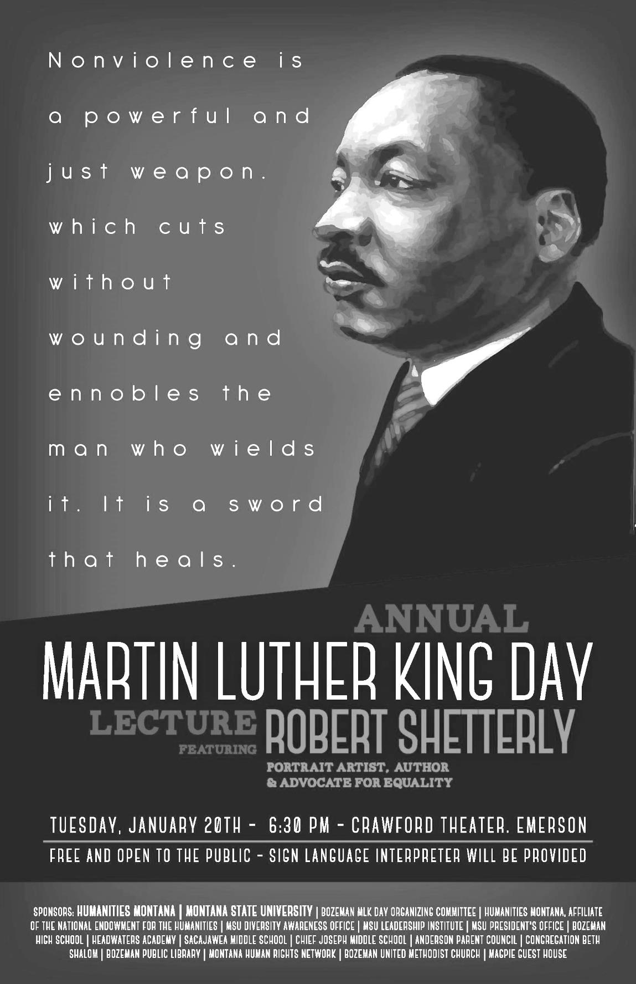

Profiles in Commitment: Ariel Donohue, 2014 Winner of the
President’s Commission on the Status of University Women Award
Ariel Donohue has been the Program Manager of MSU’s Diversity Awareness Office for almost two years. As one might imagine, her job is enormous, and her hard work, boundless energy, and dedication are notable. Ariel oversees and organizes the Safe Zone program, the Sustained Dialogue program, the LGBT Advisory Committee, annual MLK Day events, the Diversity Steering Committee, and most recently, she developed a campus wide survey on diversity and inclusion issues at MSU. On behalf of MSU, Ariel applied for and received the 2014 Higher Education Excellence in Diversity (HEED) Award from INSIGHT Into Diversity Magazine. This is the only national honor recognizing institutions of higher education for their commitment to diversity.
In her application for the PCOSUW Award, Ariel wrote: “Gender equality and diversity have been my academic, professional, and personal passions since my undergraduate years at The College of New Jersey. While pursuing my Bachelor’s degree in Women’s and Gender Studies, I served a term as President of the Gender Studies Honor Society (Iota Iota Iota) and was an active member of Women in Learning and Leadership (WILL). Through my involvement with these two groups, I immersed myself in gender issues and advocating for the rights of all underrepresented groups.” As we all know too well, Ariel’s work is far from complete, but we have no doubt that she will continue to fight the good fight for many years to come. We applaud the committee’s choice for this prestigious award, as Ariel is a role model for us all!

The FWord Feminist Discussion Student Group Update
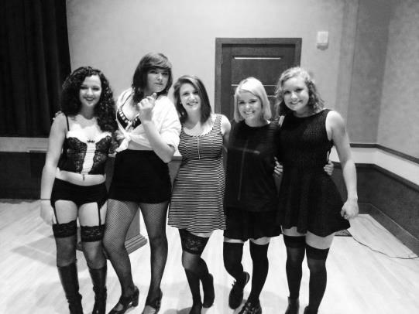
The F-Word had a lot of fun this semester. As always, every Tuesday at 7pm we met for snacks, conversations, and good times. We started out the semester by sewing t-shirts with big Venus symbols on the front. We had a spaghetti dinner at one member’s house and several of us attended the Rocky Horror Picture Show screening at the Procrastinator (pictured to the left). On October 26th, our fearless leader, Fran, spoke to the Sustained Dialogue group about the negative impacts of gendered and hyper-sexualized Halloween costumes. A screening of the To Do List featuring great femme actress, Audrey Plaza and a PJ movie party in the Procrastinator served as our Halloween celebration.
Next semester, we will have a regular meeting space in the SUB Fire Place Room for our weekly Tuesday meetings at 7 p.m. We are planning a “Galentines” Day event on February 13th to celebrate the great women in our lives! We will donate proceeds to a local women’s clinic. We will also co-sponsor a STEM panel discussion with the Women’s Center, and possibly plan a “My Body, Myself” workshop. No matter what we do, the F-Word will be meeting regularly on Tuesdays for anyone who wants a fresh insight into the feminist frame of mind. As always you can contact us as msufword@gmail.com. See you in January!
VOICE 101 Trainings: At the VOICE Center, we believe that everyone plays a vital role in helping to transform attitudes and actions regarding sexual assault, relationship violence, and stalking. We are inviting you to spend a day with us to learn how you can help prevent violence, support survivors, and create a safer community.
Becoming a VOICE Center volunteer provides students with an opportunity to become involved with positive change on campus while learning valuable peer advocacy and education skills. In addition, students may be able to receive paraprofessional or internship credits from some departments.
VOICE Center 101 Volunteer Trainings
The VOICE Center 101 Training is being offered twice this Spring: Saturday, January 24th and Saturday, February 14th to anyone who is interested in learning more about the issues impacting our campus and how they can get involved to help create change. The training is FREE and open to all MSU staff members and students (both current and incoming). Successful completion of the VOICE Center 101 training is a prerequisite to becoming a VOICE Center peer educator and/or advocate.
If you have any additional questions or want more information, please don’t hesitate to call us at 406-994-7662, email us at msuvoice@gmail.com, or stop by our office in the SUB – room 370 (above Avogadro’s Number & Leigh Lounge).

