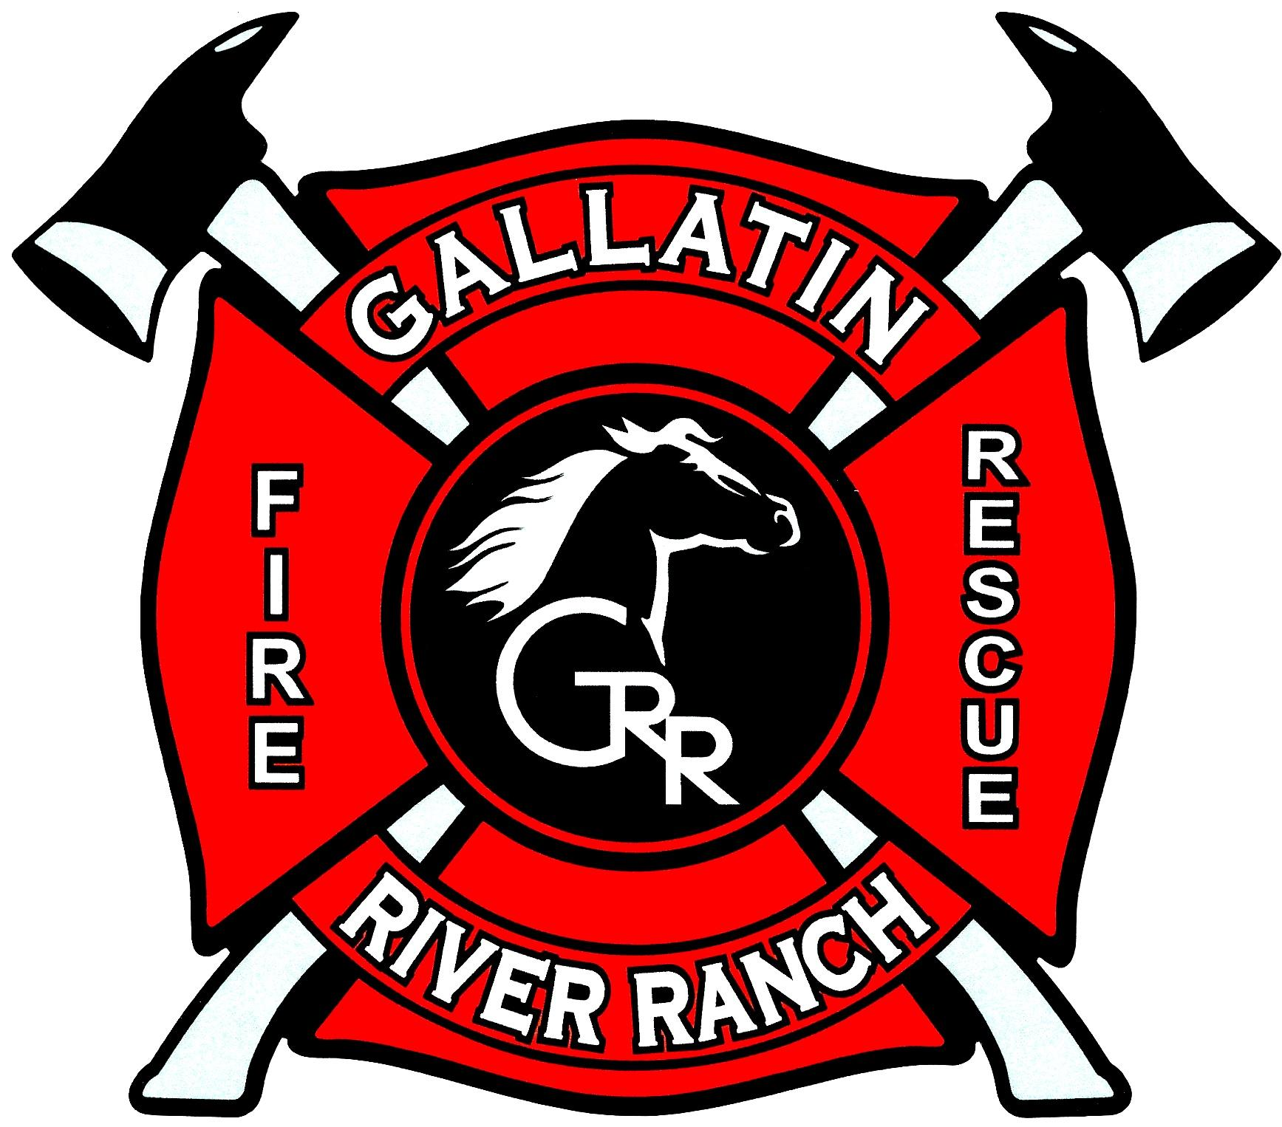

MEDICAL CALL ACTION PROTOCOL

Assume everyone you serve, medical or fire, has COVID-19

COVID-19 is without symptoms at the start. Therefore, in this pandemic, we have to assume that everyone we encounter has COVID-19, whether they know it or not. We have an obligation to protect the safety of our firefighters and EMTs by intelligent application of medical PPE. This is no different in philosophy and science than the measures we take to protect firefighters with firefighting PPE in a structure fire.

COVID-19 SYMPTOMS
In the event of a call for a patient with respiratory difficulties including the following symptoms:
- Fever (>100.4 degrees F)
- Shortness of Breath (or respiratory distress)
- Cough
- Chest pain or tightness
- Other possible symptoms:
  - Muscle aches and pains
  - Loss of sense of taste or smell

PPE DEFINITIONS
FULL-PATIENT-CONTACT PPE (and order of donning; reverse order for doffing):
- Washable coveralls (EMS or wildland)
- Gown
- N95 face mask respirator
- Goggles or face shield (full coverage eye shields are acceptable on EMT-2 and are acceptable on EMT-1 if no full goggles are available)
- Head cover (not used by many departments; GRRFD policy)
- EMS gloves
- (Simple mask in pocket for patient use. Not a part of the donning/doffing sequence.)

NO-PATIENT-CONTACT INTERIOR PPE:
- EMS Gloves
- Surgical mask
- Full coverage eye shields
- Simple face mask in pocket for patient use.
NO-PATIENT-CONTACT EXTERIOR PPE:
- EMS Gloves
- Surgical mask available but not on.
EXTERIOR:
- The exterior of a dwelling.
- The exterior of an outside scene is a safe distance away, typically 20 feet or greater
INTERIOR:
- The interior of a home or within 20 feet or a defined room in a commercial structure
- The area within about 20 feet of an outside scene.

TEAM MEMBER ROLES:
INCIDENT COMMANDER (IC)
- Wear NO-PATIENT-CONTACT PPE
OTHER FIREFIGHTERS
- Wear NO-PATIENT-CONTACT PPE.
FIREFIGHTER/EMTs
- Wear washable coveralls if possible.
- PPE suite is determined by role below:
EMT-1
- FULL-PATIENT-CONTACT PPE.
EMT-2
- NO-PATIENT-CONTACT PPE.
- Waits outside scene until ordered in by EMT-1
  - Enters the scene when ordered to do so by EMT-1.
- Remains more than 6 feet from the patient if at all possible.
  - Note-taker and GOFER if at all possible.
RESERVE EMTs
- NO-PATIENT-CONTACT EXTERIOR PPE if assigned to the exterior.
- NO-PATIENT-CONTACT INTERIOR PPE if assigned as EMT-2.
MEDICAL SAFETY OFFICER
- NO-PATIENT-CONTACT EXTERIOR PPE.
- Stays near QRU unless ordered by IC otherwise
- Runs Pre-entry Checklist while team does Pre-Entry Time-out.

One firefighter may enter the scene wearing NO-PATIENT-CONTACT PPE if ordered to do so by IC in order to assess the scene before the arrival of the rest of the EMS team. This “scout” will stay more than 6 feet away and as far away as possible from the patient while maintaining visual and voice contact with the patient. This “scout” will not touch the patient.

Only EMT-1 will touch the patient or work within 3 feet of the patient.

EMT-2 will remain more than 6 feet away from the patient except in CPR or, if in EMT-1s judgement, EMT-2 must directly assist. If EMT-2 approaches within 6 feet of the patient, a gown is recommended if available. EMT-2 should wear an N95 respirator if a high risk respiratory procedure is anticipated or planned.

The LifePak and Interior Med Kit will be placed 6 feet from the patient if possible and will be managed by EMT-2 to the greatest degree possible.

All disposable PPE and equipment will be placed in biohazard bags and managed by the Medical Safety Officer.

All non-disposable equipment used will be decontaminated by the EMTs under the supervision of the Medical Safety Officer.

All reusable coveralls will be placed in a plastic trash bag and taken to the fire department laundry area to be machine washed with standard laundry detergent and hot water.

MEDICAL SAFETY OFFICER CHECKLIST

DATE:______________________
LAST NAME: _____________________

PRE-ENTRY CHECKLIST

EMT-1 designated and wearing coveralls
Gloves
Head cover
Goggles or eye protection
N95 or Surgical Mask
Gown
EMT-2 designated and wearing coveralls
Gloves
Goggles or eye protection
Surgical Mask
LifePak
Interior Med Kit
Radios on assigned GTAC
Pre-entry Time-out

POST INCIDENT CHECKLIST
All personnel and equipment present
Personnel doff PPE using proper order and methods
Provide paper bag for N95 Mask reuse as indicated
Hold open biohazard bag for each member to dispose of PPE
Dispense hand sanitizer (squirt it into their open hands)
Provide fresh gloves to all personnel
Set all used non-disposable personal equipment on paper towels
Observe each member disinfect their personal equipment
Disinfect non-disposable QRU equipment that was in patient contact
Replace and secure equipment into QRU
Hold open large trash bag for team to place coveralls into and place bag in QRU
Doff gloves and place in biohazard trash bag
Dispense hand sanitizer
Dispose of biohazard bag in regular trash at Station 1
Give used coverall bag to Chief or Medical Officer to launder
The only team member in QRU compartment is the Medical Safety Officer

