# Program Assessment Report

Academic Year(s) Assessed: Summer 2022—Spring 2024

College: College of Letters & Science  
Department: Ecology

Department Head: Diane Debinski  
Submitted by: Diane Debinski

Date: 10/9/24

**Program(s) Assessed** **Graduate Biennial Program Assessment Report**  
*List all majors (including each option), minors, and certificates that are included in this assessment – add or subtract rows as needed – please use official titles:*

|  |  |
| --- | --- |
| **Majors** | **Minors, Options, etc.** |
| PhD Biological Sciences  PhD Fish and Wildlife Biology  PhD in Ecology & Environmental Science (intercollege) |  |
| MS Biological Sciences  MS Fish and Wildlife Management |  |

1. **Past Assessment Summary.**

Our graduate program has been strong and our students have been highly successful in the major steps required to obtain their degrees. The implementation of two graduate courses (see below for details), required by all M.S. students and serving as an option for all Ph.D. students, has provided students with a solid background in our discipline and strong scientific communication skills.

1. **Action Research Question.**

One issue that arose during this review was the question of the qualifying exam. Our students are not having difficulty passing the qualifying exam, but the faculty discussed whether it should be required for all M.S. and Ph.D. students, under what circumstances, and how to better standardize the format of the exam across committees. See #6 below for more details.

1. **Assessment Plan, Schedule, and Data Sources.**
2. Please provide a multi-year assessment schedule that will show when all program learning outcomes will be assessed, and by what criteria (data).

The full program of study is determined by the graduate committee following the Graduate School [degree requirements](http://www.montana.edu/gradschool/policy/degreq_masters.html), usually after the student has completed the oral qualifying exam during the second semester in the program for MS degrees or by the end of the third semester for PhD degrees. Current degree requirements are in the [Graduate Catalog](http://catalog.montana.edu/graduate/letters-science/ecology/ms-biological-sciences/). All graduate degrees in Ecology fall under Plan A: Thesis

|  |  |  |  |
| --- | --- | --- | --- |
| ASSESSMENT PLANNING SCHEDULE CHART | | | |
| PROGRAM LEARNING OUTCOMES | 2022-2023 | 2023-2024 | ***Data Source\**** |
| Demonstrate a substantive breadth of knowledge of the field and sub-disciplines of ecology | X | X | Qualifying Exam & Foundations of Ecology & Mgmt. Course BIOE554:  Comprehensive testing on broad ecological knowledge  Oral presentations  Literature synthesis |
| Demonstrate effective written and oral communication of scientific material, both from original and other sources | X | X | Comprehensive Exam and Communications in Ecol. Sciences BIOE 555: Written and oral communications in multiple formats |
| Conduct substantive original research and produce written and oral reports of the body of work | X | X | Thesis/Dissertation Defense:  Ability to conduct original research and produce written and oral reports of the body of work. |
| Conduct scholarly and professional activities in an ethical manner | X | X | Body of work shows good understanding of ethical conduct of research as determined by grad committee.  Federally funded students complete CITI Responsible Conduct or Research Training |
| **PhD students only:** Contribute to the development of the field of ecology and/or scientifically based natural resource management | X | X | Refereed publications, poster & oral presentations at national and international meetings |

b) What are the threshold values for which your program demonstrates student achievement?

|  |  |  |  |
| --- | --- | --- | --- |
| PROGRAM LEARNING OUTCOME | Threshold Value  (individual student based) | Results | Data Source |
| Demonstrate a substantive breadth of knowledge of the field and sub-disciplines of ecology | Passing BIOE 554 (Foundations of Ecology & Mgmt.) and passing Qualifying Exam | For 2022-2023:  **6** Ecology grad students took BIOE 554 (Foundations of Ecology & Mgmt.) and passed. **4** MS and **1** PHD took and passed their qualifying exam, no students failed the course or their exams.  For 2023-2024:  **12** Ecology grad students took BIOE 554 (Foundations of Ecology & Mgmt) and passed. **6** MS and **2** PHD took and passed their qualifying exam and passed, no students failed the course or their exams. | Qualifying Exams, Foundations Course BIOE 554 |
| Demonstrate effective written and oral communication of scientific material, both from original and other sources | Passing BIOE 555 (Communications in Ecol. Sciences) and passing Qualifying Exam and/or Successfully defend Thesis/Dissertation | For 2022-2023:  **9** Ecology grad students took BIOE 555 (Communications in Ecol. Sciences) and passed. **4** MS and **1** PHD took and passed their Qualifying Exam, no students failed the course or their exams. **4** MS and **2** PhD students successfully defended their thesis/dissertation  For 2023-2024: **12** Ecology grad students took BIOE 555 (Communications in Ecol. Sciences) and passed. **6** MS and **2** PHD took Qualifying Exam and passed, no students failed the course or their exams. **8** MS and **3** PhD students successfully defended their thesis/dissertation | Qualifying Exams, Communications course BIOE 555, Thesis/Dissertation Defense |
| Conduct substantive original research and produce written and oral reports of the body of work | Passing Comprehensive Exam and/or Successfully defend Thesis/Dissertation | For 2022-2023:  **4** MS successfully defended their theses and passed their Comps. **2** PhD students successfully defended their dissertation, and 4 students passed their Comprehensive exam  For 2023-2024:  **8 MS** successfully defended their theses. **3** PhD students successfully defended their dissertation and passed their Comprehensive exam | Comprehensive Exams, Thesis/Dissertation Defense |
| Conduct scholarly and professional activities in an ethical manner | Passing Comprehensive Exam and/or Successfully defend Thesis/Dissertation | For 2022-2023:  **4 MS** successfully defended their theses. **2** PhD students successfully defended their dissertation.  For 2023-2024:  **8** MS successfully defended their theses. **3** PhD students successfully defended their dissertation  **5** students completed their RCR training over the duration of this report. | Comprehensive Exams, Thesis/Dissertation Defense/CITI Course Completion on Responsible Conduct of Research (RCR) if required |
| Additional Program Learning Outcomes for PhD students: |  |  |  |
| Contribute to the development of the field of ecology and/or scientifically based natural resource management | Acceptance of manuscript for publication, Presentation at Scientific Meeting, Outreach to Professional Practitioners | All PhD candidates are evaluated by their committee for scholarly works. Ecology graduate students (both M.S. and Ph.D.) are successfully publishing the results of their research, as summarized in Appendix 1. In 2022 42 ecology graduate students were authors or co-authors on 33 publications, 32 students co-authored 22 publications in 2023 and 17 students have co-authored on 14 publications thus far for 2024. | Publication in Scientific Literature, Presentation at Scientific Meeting, Outreach to Professional Practitioners |

1. **What Was Done.**
2. Self-reporting Metric (required answer): Was the completed assessment consistent with the program’s assessment plan? If not, please explain the adjustments that were made.

Yes No

**X**





## How were data collected and analyzed and by whom? Please include method of collection and sample size.

Data were collected on each student in each course and by M.S. and Ph.D. student cohorts for each year. A synthesis of these data was completed by the department head and a draft of the report was shared with the faculty prior to a faculty meeting. Results were discussed at a faculty meeting. Sample sizes varied based upon class size, but all students were evaluated by class and by cohort.

## Please provide a rubric that demonstrates how your data were evaluated.

**Example: BIOE55 Communication in Ecological Sciences– Requirements from Syllabus and Rubric for Student Presentations**

**Presentation Descriptions** (all presentations need to have an ecological theme)**:**

• 15-minute professional paper presentation (~23 minutes total; 15 for presentation, 5 for questions, 3 for audience to complete evaluation form)

This presentation represents the introduction of your thesis or dissertation and provides the foundation for your 15-minute presentation without slides (see below). For this presentation, you will select journal articles that are central to your introduction and overall research question. You will use the articles to explain the background to the research need, demonstrate how your research fits into the body of knowledge on the subject, and convince the audience that your research is important. Your presentation should explain the article(s) such that the audience can understand the foundational research that has led to your research. Your presentation should end with a “so what” that can be used as a segue to your 15-minute presentation without slides (see below).

**THIS PRESENTATION SHOULD BE DATA RICH AND JARGON IS APPROPRIATE**.

**YOU MUST INCLUDE AT LEAST TWO FIGURES AND ONE TABLE IN YOUR**

**PRESENTATION.** That is, reproducing tables and figures from the articles is appropriate, but remember to use the guidelines for making good slides. Be careful when directly copying tables and figures from manuscripts because they often are not suitable for presentations because they typically contain too much detail. Furthermore, scanned images from journal articles can be pixelated in a PowerPoint presentation.

• 15-minute presentation without slides (~23 minutes total; 15 for presentation, 5 for questions,

3 for audience to complete evaluation form)

For this presentation, you will present your thesis or dissertation topic without using

PowerPoint (or any similar software). You can bring in visual aids such as tags, traps, or mounts—be creative in your presentation style. The presentation should be a continuation of your 15-minute presentation with slides (see above) and focus on the research need (i.e., remind the audience how this research will benefit the species, ecosystem, and/or society), your research hypotheses, predictions, methods, and results (results are not required because many of you will be in the early stage of your program). You can also include any conclusions, but we expect this will be rare given where you are in your graduate education timeline. You can use this presentation to obtain feedback from the audience on your proposed research. We encourage engaging the audience in this presentation.

• 6-minutes of Science presentation

For this presentation, you will follow a style similar to the PechaKucha format, but the number of slides is your choice and slides will not automatically advance. This presentation will be formatted for the lay audience and could be on a topic that you are familiar with, but not directly related to your thesis or dissertation topic.

• Podcast interview

You will be interviewed (by Chris Guy or Andrea Litt) for the podcast titled Today’s Voices of Conservation Science, and we will use interviews of students in this class to populate many of the podcast episodes. The podcast interviews should be fun, low-key, relaxed, informative, and focused on communicating your science and passion to the lay audience. The podcast will be ~20-minutes long, but the interview process will be about 45 minutes to an hour. To prepare for the podcast please respond to these questions prior to the podcast via an e-mail to Chris—this will allow us to prepare for the conversation. The responses can be a couple of sentences for each question and then we will fill in the details during the interview:

• Introduction and biographical information (50-70 words)

• What compelled you to pursue a career in conservation?

• Who or what was instrumental in getting you interested in conservation and nature?

• What hurdles did you personally face and how did you overcome them to get where you are today?

• Tell me about your research?

• Why is your research important?

• What is the best thing you could discover?

• What is your favorite animal, plant, or both?

Podcast interviews will occur in the evening (starting at 5:15 p.m.) to keep the background noise to a minimum. Please contact Dr. Guy to schedule a podcast interview on a Monday or Wednesday during the semester. Again, this should be enjoyable and casual. You can check out the podcast here http://conservationscience.buzzsprout.com or on iTunes or Stitcher.

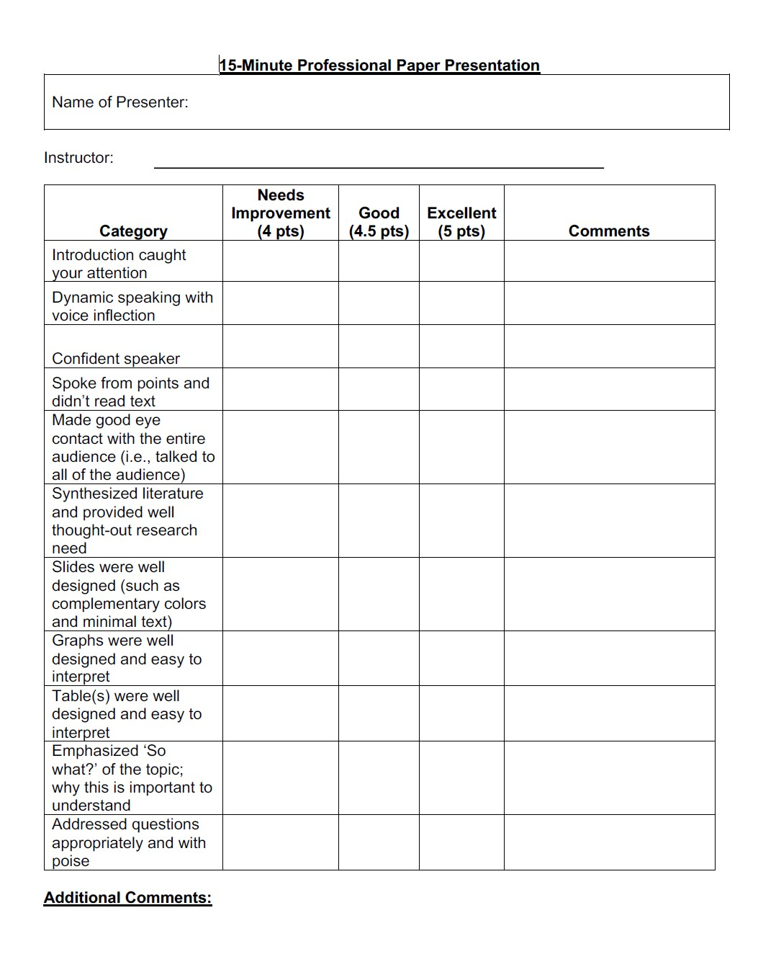

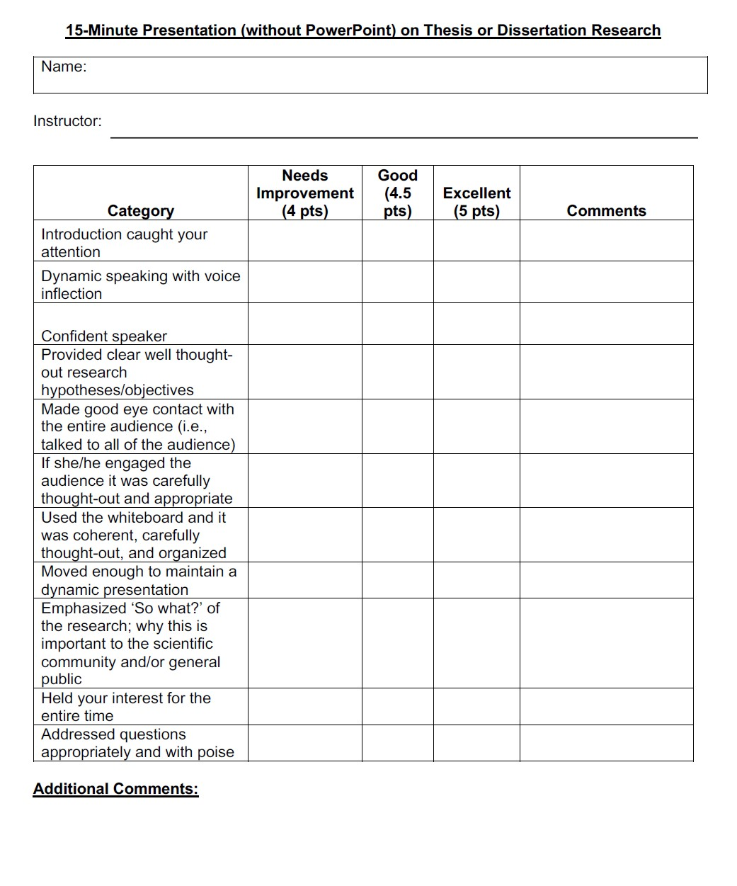

**Example: BIOE554 Foundations of Ecology and Management – Rubric for Student Presentations**

Evaluation of Presentation

Name of Presenter ________________________ Total Score________

|  |  |
| --- | --- |
| Speaking Skills |  |
| Loudness | Too quiet Just right  2 4 6 8 10 |
| Enthusiasm | low Just right  2 4 6 8 10 |
| Eye contact with audience | None Just right  2 4 6 8 10 |
| Confidence | None Just right  2 4 6 8 10 |

|  |  |
| --- | --- |
| Presentation |  |
| Timing | Too short or too long Just Right  2 4 6 8 10 |
| Format of Slides  (font size, words/slide, etc.) | Needed improvement Highly polished  2 4 6 8 10 |
| References  (embedded in talk) | Did not have references Several references  2 4 6 8 10 |
| Visual aids | Poor Quality High Quality  2 4 6 8 10 |

|  |  |
| --- | --- |
| Content |  |
| Cohesiveness of presentation | Low High  2 4 6 8 10 |
| Creativity in linking to class material | Low High  2 4 6 8 10 |

Comments:

1. **What Was Learned.**
2. Based on the analysis of the data, and compared to the threshold values established, what was learned from the assessment?

As we summarized in the 2022 report, in 2012-2014, the pass rates on graduate exams and defenses were noted to be reasonable, but the faculty believed that students did not express as broad an understanding of the discipline as desired, were rather narrowly focused on just their research, and some struggled to express themselves verbally. The curriculum initiated in 2012 for the MS students requires them to take two specific courses: BIOE 554 Foundations of Ecology and Management and BIOE 555 Communication in Ecological Sciences. These courses are not required for the Ph.D. students, but many Ph.D. students also take the courses. These courses provide an opportunity for a cohort of graduate students to interact, regardless of their subdiscipline in Ecology, which promotes “cross-pollination” within the Ecology Department across graduate majors. Enrollment from 2022-2023 in both courses has been very strong: Foundations Fall 2022 (**6**), and 2023 (**12**) and Communications Spring 2022 (**9**) and 2023(**12**). The Foundations class provides background with regard to key ecological and management topics, including classic historical literature as well as some of the newest advances in Ecology. Both classes emphasize communication skills that are essential for a career in ecology. The outcome has been especially noteworthy. Faculty have observed that students bring a broader understanding of the literature to their research, and have improved in their ability to express themselves.

1. What areas of strength in the program were identified from this assessment process?

Ecology graduate students are developing a broad set of communication skills via the Communication in Ecological Sciences course. We have cultivated a departmental culture of participating in this course because the student presentations constitute our departmental Spring Seminar. The Foundations of Ecology and Management course introduces the students to some of the more classic foundational and contemporary applications papers from a broad array of subdisciplines within Ecology and Management and the students get a chance to meet many of the faculty who each participate on a particular day and related to a particular subdiscipline. This course has become relatively popular and has had solid enrollments in 2022 and 2023, including students from several other majors (Land Resources & Environmental Sciences, Microbiology & Cell Biology, History & Philosophy, Earth Sciences). There was a slight dip to 6 students in 2022 associated with faculty retirements and thus less graduate student recruitment, but enrollment was back up to 12 in 2023. The students in this class learn both from their peers and from the faculty how to articulate thoughtful and sophisticated scientific questions evaluating the literature.

Ecology graduate students are also very successfully publishing the results of their research, as summarized in Appendix 1. In 2022 Ecology graduate students (both M.S. and Ph.D.) were authors or co-authors on 33 publications, with 22 publications in 2023 and 14 thus far for 2024. Our graduate students are publishing their work prior to completion of their degrees in many cases, and they are publishing in high impact journals. Publication of new science is the gold standard for success in STEM fields and they are achieving that goal.

In addition, a total of 5 graduate students completed Responsible Conduct of Research (RCR) training over the duration of this report, Summer 2022-Fall 2024.

1. What areas were identified that either need improvement or could be improved in a different way from this assessment process?

Some of our graduate students are taking the CITI Responsible Conduct of Research Training because it is a requirement for students who are supported by NSF Graduate Research Fellowship Program (GRFP). However, it may be valuable for a larger number of our graduate students to be involved in such programs. We will investigate options for this and other types of professional training in the future.

Over the past 2-3 years, our undergraduate population continued to increase (just under 600 students), and graduate student recruitment declined slightly. These changes are not surprising, but they are worth reflecting on in the context of impacts on our graduate program during coming years. The combination of having relatively fewer tenure-track faculty due to retirements and in the context of an increasing undergraduate population put stress on our faculty’s recruitment of new graduate students, and that was observed in the Fall 2022 graduate student numbers, which were lower than usual. Over the course of two academic years (AYs 22-23 and 23-24) we hired four new tenure-track faculty, and that has just recently given a boost to our graduate student population. We will need to continue to monitor these trends over time.

Our current number of graduate students is 56, with 33 M.S. students and 23 Ph.D. students, a ratio of ~60% M.S. to 40% Ph.D. students in Ecology. This is slightly higher in the percentage of Ph.D. students in recent years when it was closer to 66% M.S. to 33% Ph.D. students.

1. **How We Responded.**
2. Describe how “What Was Learned” was communicated to the department, or programfaculty. How did faculty discussions re-imagine new ways program assessment might contribute to program growth/improvement/innovation beyond the bare minimum of achieving program learning objectives through assessment activities conducted at the course level?

One of the topics the faculty discussed in the context of this report was the graduate qualifying exams, which are a departmental requirement for both M.S. and Ph.D. students. Ph.D. students who have taken qualifying exams in the MSU Ecology Dept. as M.S. students are exempt from these exams whereas Ph.D. students who have taken qualifying exams in a different department or university as M.S. students are not exempt from these exams. We discussed whether this was a reasonable policy. The faculty agreed that qualifying exams are important for all M.S. students, but may not be essential for Ph.D. students who have already completed qualifying exams at other institutions. We are going to revisit this question over the next several months. We also discussed how to be more consistent across committees in administering qualifying exams.

1. How are the results of this assessment informing changes to enhance student learning in the program?

We are considering whether we need to update our list of example qualifying exam questions that are included in the Graduate Student Handbook for students to review as they prepare for their exams. These questions were written several years ago and there may be new topics that need to be covered.

1. If information outside of this assessment is informing programmatic change, please describe that.

The graduate school no longer requires qualifying exams. The Ecology Department has decided to retain the requirement of qualifying exams because we think they are an important step in preparing graduate students for later oral exams with their committee, such as their defense.

1. What support and resources (e.g. workshops, training, etc.) might you need to make these adjustments?

Faculty time is needed to update example qualifying exam questions that are listed in our graduate handbook. No other resources are required.

## 7. Closing the Loop(s). Reflect on the program learning outcomes, how they were assessed in the previous cycle (refer to #1 of the report), and what was learned in this cycle. What action will be taken to improve student learning objectives going forward?

## Self-Reporting Metric (required answer): Based on the findings and/or faculty input, will there any curricular or assessment changes (such as plans for measurable improvements, or realignment of learning outcomes)?

No

Yes



**X**



## In reviewing the last report that assessed the PLO(s) in this assessment cycle, what changes proposed were implemented and will be measured in future assessment reports?

We did not have any major concerns with our graduate program. Our graduate program is strong and growing, there is excellent faculty support for graduate students in our department, and students are completing their degrees with a high level of success. We will be considering updating policies on qualifying exams prior to the next review.

## Have you seen a change in student learning based on other program adjustments made in the past? Please describe the adjustments made and subsequent changes in student learning.

We have not seen any major changes in student learning based on program adjustments since the last report. There were no major adjustments.

**Appendix 1: Ecology Publications with Graduate Student Authors**

**(* Denotes Graduate Student from the Department of Ecology; ** denotes Affiliate of the Department of Ecology, bold with no * denotes Ecology faculty)**

**2024 Publications**

**Albertson, L.K.**, Sklar, L.S., **Tumolo*, B.B., Cross, W.F.**, Collins, S.F., & Woods, H.A. (2024). The ghosts of ecosystem engineers: Legacy effects of biogenic modifications. *Functional Ecology*, 38, 5272.  <https://doi.org/10.1111/1365-2435.14222>

Anderson, A.K.,**Levinson*, P.M.**, Conklin, A., **Rotella, J.J.**(2024) Observations of Weddell seal (*Leptonychotes weddellii*) supernumerary nipples. *Polar Biol* **47**, 425-429.  <https://doi.org/10.1007/s00300-024-03228-x>

**Bowersock, N. R.*, Litt, A.R.,** Sawaya, M.A., Gunther, K.A., and van Manen, F.T. (2024) Spatial variation in black bear density on Yellowstone’s Northern Range. Journal of Wildlife Management 88: e22497. doi: 10.1002/jwmg.22497

**Briggs*, M. A., Glassic*, H. C., Guy, C. S.**, Opitz, S. T., **Rotella, J. J.**, & Schmetterling, D. A. (2024). Adapting standardized trout monitoring to a changing climate for the upper Yellowstone River, Montana, USA. *North American Journal of Fisheries Management*, 00, 1–1. <https://doi.org/10.1002/nafm.11026>

**Glassic*, H.C.**, Chagaris, D.D., **Guy, C.S.**, Tronstad, L.M., Lujan, D.R., **Briggs*, M.A., Albertson, L.K.**, Brenden, T.O., Walsworth, T.E. and Koel, T.M. (2024), Yellowstone Cutthroat Trout Recovery in Yellowstone Lake: Complex Interactions Among Invasive Species Suppression, Disease, and Climate Change. *Fisheries*, 49: 55-70. <https://doi.org/10.1002/fsh.10998>

**Glassic*, H.C.,  J**unker. J.R., **Guy, C.S,** Lujan, D.R., Tronstad, L.M., **Briggs*, M.A , Albertson,**L.K., Brendan, T.O.,  Walsworth, T., and  Koel., T.M. (2024) An invasive predator substantially alters energy flux without changing food web functional state or stability. *Aquatic Conservation: Marine and Freshwater Ecosystems*34:e4240*.*

**Glenny*, W.R.**, Runyon, J.B., **Burkle, L.A.** (2024) Bumble bee diet breadth increases with local abundance and phenophase duration, not intraspecific variation in body size. *Oecologia* **205**, 149–162.  <https://doi.org/10.1007/s00442-024-05560-9>

**Hansen, A.J**., Aragon-Osejo, J., Gonzalez, I.,**Veneros*, J**....et al. (2024) Developing national complementary indicators of SDG15 that consider forest quality:  Applications in Columbia, Ecuador, and Peru.  Ecological Indicators, v. 159. <https://doi.org/10.1016/j.ecolind.2024.111654>

**Hilty*, S.L.,  Litt, A.R.**, Maxell, B.A., Gower, C.N., **Garrott, R.A.**, Hanauska-Brown, L.  (2024) Characterizing diurnal roosts of male Little Brown Myotis (*Myotis lucifugus*) during summer, *Journal of Mammalogy*, V. 105:3, 652–666, <https://doi.org/10.1093/jmammal/gyae022>

**Junker*, J.R., Cross, W.F.**, Hood, J.M., Benstead, J.P., Huryn, A.D., Nelson, D., Ólafsson, J.S. and Gíslason, G.M. (2024) Environmental warming increases the importance of high‐turnover energy channels in stream food webs. *Ecology*, p.e4314.

Landsman, A.P., **Simanonok*, M.P.**, Savoy-Burke, G., Bowman, J.L., andDelaney, D.A. (2024)Geographic Drivers More Important than Landscape Composition in Predicting Bee Beta Diversity and Community  Structure.” *Ecosphere* 15(4): e4819. <https://doi.org/10.1002/ecs2.4819>

**Loggers*,E. A., Litt, A.R.**, van Manen, F.T.,Haroldson, M.A., andGunther, K.A. (2024)Grizzly bear responses to restrictions of recreation in Yellowstone National Park. *Journal of Wildlife Management,* 88:e22527. <https://doi.org/10.1002/jwmg.22527>

**Meinzen*, T.C., L.A. Burkle**, and **D.M. Debinski**. 2024. Roadside habitat: boon or bane for pollinating insects? *BioScience*.74:54-64 <https://doi.org/10.1093/biosci/biad111>

Walsworth, T.E., Fadlovich, R., **Heinle*, K.B**. ...et al. (2024)  Interactions between runoff volume, timing, and annual temperatures shape migration phenology of a threatened adfluvial sucker. *Ecology of Freshwater Fish*, 00, e12791. <https://doi.org/10.1111/eff.12791>

**2023 Publications**

**(* Denotes Graduate Student from the Department of Ecology)**

Argueta-Guzmán, M., West, M., Gaiarsa, M.P. ...**Gedlinski*, L.**, ...*et al.*  (2023)  Words matter: how ecologists discuss managed and non-managed bees and birds. *Scientometrics* 128, 1745-1764.   <https://doi.org/10.1007/s11192-022-04620-2>

Bertagnolli, A.D., Maritan, A.J., **Tumolo*, B.B., Fritz*, S.F.**, Oakland, H.C., Mohr, E.J., Poole, G.C., **Albertson, L.K.** (2023) Net-spinning caddisflies create denitrifier-enriched niches in the stream microbiome. *ISME Communications* 3:111.

Cox TL, Lance MJ, **Albertson LK**, **Briggs* MA**, Dutton AJ, **Zale, A.V.**  (2023) Diet composition and resource overlap of sympatric native and introduced salmonids across neighboring streams during a peak discharge event. PLOS ONE 18(1): e0280833. <https://doi.org/10.1371/journal.pone.0280833>

**Creel, S.**, **Becker**, M.S.**,**Goodheart*, B., Reyes de Merkle*, J.**, Dröge, E., M'soka, J., Rosenblatt, E....**Smit*, D.**, *et al.* (2023) Habitat shifts in response to predation risk are constrained by competition within a grazing guild. *Frontiers in Ecology,*v. 2. <https://doi.org/10.3389/fetho.2023.1231780>

**Creel, S.**, Becker, M.S., **Reyes de Merkle*, J., Goodheart*, B.**(2023) Hot or hungry?  A tipping point in the effect of prey depletion on African wild dogs.  *Biological Conservation, v. 282*[*https://doi.org/10.1016/j.biocon.2023.110043*](https://doi.org/10.1016/j.biocon.2023.110043)

Daigle, N.J., Djokic, M.A., Kappenman, K.M., Gaylord, T.G., **Quinn*, S., Verhille, C.**  (2023) Validation of a microwave energy meter to non-lethally estimate energetic reserves in adult sturgeon, *Conservation Physiology*, Volume 11, Issue 1, coad023, <https://doi.org/10.1093/conphys/coad023>

**East*, A.**; **Hansen, A.**; Armenteras, D.; Jantz, P.; **Roberts, D.W.** (2023) Measuring Understory Fire Effects from Space: Canopy Change in Response to Tropical Understory Fire and What This Means for Applications of GEDI to Tropical Forest Fire. *Remote Sens.* *15*, 696. <https://doi.org/10.3390/rs15030696>

**Eckelbecker*, R.W.**; Heili, N.M.; **Guy, C.S.**; Schmetterling, D.A. (2023) Relative Condition Parameters for Fishes of Montana, USA. *Fishes* v. 8:28. <https://doi.org/10.3390/fishes8010028>

**Fritz\***, **S.F.**,**Albertson, L.K.**, Hobgood, J.L., Mohr, E.J., Oakland, H.C., Poole, G.C.  (2023) Macroinvertebrate ecosystem engineering affects streambed retention of microplastics.  *Freshwater Science.*[*https://doi.org/10.1086/724584*](https://doi.org/10.1086/724584)

**Glassic*, H.C., Guy, C.S.**, Tronstad, L.M., **Briggs*, M.A., Albertson, L.K.**, Lujan, D.R., Koel, T.M.  (2023) Decomposition rates of suppression-produced fish carcasses in a large, deep, high-elevation lake in North America. *Fishes, 8(8):385.*[*https://doi.org/10.3390/fishes8080385*](https://doi.org/10.3390/fishes8080385)

**Glassic*, H.C., Guy, C.S.**, Tronstad, L.M., Lujan, D.R., **Briggs*, M.A., Albertson, L.K.**, Koel, T.M. (2023) Invasive predator diet plasticity has implications for native fish conservation and invasive species suppression. *PLoS One 18(2): e0279099.*[*https://doi.org/10.1371/journal.pone.0279099*](https://doi.org/10.1371/journal.pone.0279099)

**Glenny*, W.G.**, Runyon, J.B., **Burkle, L.A.** (2023)  Habitat characteristics structuring bee communities in a forest-shrubland ecotone.  *Forest Ecology Management, v. 534,*[*https://doi.org/10.1016/j.foreco.2023.120883*](https://doi.org/10.1016/j.foreco.2023.120883)

**Glenny*, W.G.**, Runyon, J.B., **Burkle, L.A.** (2023) Plant selection for pollinator restoration in seminatural ecosystems. *Frontiers in Ecology and the Environment, v.21:3, p. 148-156.*[*https://doi.org/10.1002/fee.2595*](https://doi.org/10.1002/fee.2595)

Koel, T.M., Doepke, P.D., MacDonald, D.J., Thomas, N.A., Vender, C.W., **Glassic*, H.C.**, Poole, A.S., **Guy, C.S.** and **Zale, A.V.** (2023), Aerial Application of Organic Pellets Eliminates Lake Trout Recruitment from a Primary Spawning Reef in Yellowstone Lake. *North Am J Fish Manage,* 43: 505-516. <https://doi.org/10.1002/nafm.10872>

**Macdonald*, K.R., Rotella, J.J., & Paterson*, J.T.** (2023). Evaluating the importance of individual heterogeneity in reproduction to Weddell seal population dynamics using integral projection models. *Journal of Animal Ecology*, 92, 1828–1839. <https://doi.org/10.1111/1365-2656.13975>

Petch, S. M., **Rotella, J. J.**, Link, W. A., **Paterson*, J. T.**, & **Garrott, R. A.** (2023). Investigating diverse sources of variation in the amount of time Weddell seal (*Leptonychotes weddellii*) pups spend in the water during the lactation period. *Marine Mammal Science*, 39( 1), 6– 21. <https://doi.org/10.1111/mms.12955>

**Scholl*, E.A.**, **Cross, W.F. and Guy, C.S.** (2023) Geomorphology shapes relationships between animal communities and ecosystem function in large rivers. Oikos, 2023: e09431. <https://doi.org/10.1111/oik.09431>

**Scholl*, E.A.**, **Cross, W.F., Guy, C.S.**, Dutton, A.J. & Junker, J.R. (2023) Landscape diversity promotes stable food-web architectures in large rivers. *Ecology Letters*, 26, 1740–1751. Available from: <https://doi.org/10.1111/ele.14289>

Tronstad, L. M., Lujan, D.R., **Briggs*, M.A.,Albertson, L.K., Glassic*, H.C., Guy, C.S.**, and Koel, T.M. (2024) Novel technique for suppressing an apex invasive predator minimally alters nitrogen dynamics in Yellowstone Lake, Wyoming, USA. Hydrobiologia 851: 2215 - 2236

**Tumolo*, B.B., Albertson, L.K., Cross, W.F**., Poole, G.C., Davenport, G., Daniels, M.D. and Sklar, L.S. (2023) Resource modification by ecosystem engineers generates hotspots of stream community assembly and ecosystem function. Ecology. Accepted Author Manuscript e4052. <https://doi.org/10.1002/ecy.4052>

**Tumolo*, B.B., Albertson, L.K.**, Daniels, M.D., **Cross, W.F.**, & Sklar, L.L. (2023). Facilitation strength across environmental and beneficiary trait gradients in stream communities. *Journal of Animal Ecology*, 92, 2005-2015. <https://doi.org/10.1111/1365-2656.13992>

**Ulrich, D.E.M**, **Wasteneys*, C., Hoy-Skubik*, S., Alongi*, F.**(2023)  Functional traits underlie specialist-generalist strategies in whitebark pine and limber pine.  F*orest Ecology and Management.*v. 542. 121113. <https://doi.org/10.1016/j.foreco.2023.121113>

**2022 Publications**

**(* Denotes Graduate Student from the Department of Ecology)**

**Albertson, L.K.,Briggs*, M.A.,Maguire*, Z.,**Swart, S., **Cross, W.F.,**Twining, C. W.,Wesner, J.S.,Baxter, C.V., andWalters, D.M. (2022) “Dietary Composition and Fatty Acid Content of Giant Salmonflies (*Pteronarcys Californica*) in Two Rocky Mountain Rivers.”*Ecosphere*13(1): e3904.  <https://doi.org/10.1002/ecs2.3904>

**Albertson, L.K.**, Ouellet, V., **Reinert*, J.H.**, Korb, N., Jaeger, M. (2022) Influence of beaver mimicry restoration on habitat availability for fishes, including Arctic grayling (*Thymallus arcticus*).*Aquaculture, Fish, and Fisheries*2:104-115. <https://doi.org/10.1002/aff2.30>

**Bowersock, N. R.**\*, Okada, H., **Litt, A.R.**, Gunther, K.A., and van Manen, F.T.**(**2022) Rub tree use and selection by bears in northern Yellowstone.*Ursus*33:e7. doi: 10.2192/URSUS-D-21-00009.3

**Briggs*, M.A., Albertson, L.K.**, Lujan, D.R., Tronstad, L.M., **Glassic*, H.C., Guy, C.S.**, and Koel, T.M. (2022) Fish carcass deposition to suppress invasive laketrout through hypoxia causes limited, non-target effects on benthic invertebrates in Yellowstone Lake. *Aquaculture, Fish, and Fisheries*2:470-483*.*

**Djokic*, M. A.**, Heishman, J., Kappenman, K. M., Gaylord, T. G., & **Verhille, C. E**. (2022) A microwave energy meter to estimate energetic reserves in juvenile sturgeon. *Journal of Applied Ichthyology*, 38, 149-156. <https://doi.org/10.1111/jai.14311>

**Durney*, J. S.**, Engel, A., **Debinski, D. M.**, and **Burkle, L.A.** (2022)Earlier Spring Snowmelt Drives Arrowleaf Balsamroot Phenology in Montane Meadows.  *Ecosphere* 13( 8): e4198. <https://doi.org/10.1002/ecs2.4198>

Fay, R., Authier, M., Hamel, S., Jenouvrier, S., van de Pol, M., Cam, E., Gaillard, J.-M., Yoccoz, N. G., Acker, P., Allen, A., Aubry, L. M., Bonenfant, C., Caswell, H., Coste, C. F. D., Larue, B., Le Coeur, C., Gamelon, M., **Macdonald*, K. R**., Moiron, M., **Rotella, J.**, … Sæther, B.-E. (2022) Quantifying fixed individual heterogeneity in demographic parameters: Performance of correlated random effects for Bernoulli variables. *Methods in Ecology and Evolution*, 13, 91– 104. <https://doi.org/10.1111/2041-210X.13728>

Fay, R., Hamel, S., van de Pol, M., Gaillard, J.-M., Yoccoz, N.G., Acker, P....**Macdonald*, K**.,....**Rotella, J.**,,,, et al. (2022) Temporal correlations among demographic parameters are ubiquitous but highly variable across species. *Ecology Letters*, 25, 1640– 1654. Available from: <https://doi.org/10.1111/ele.14026>

**Flesch*, E.**, Graves, T., Thomson, J., **Proffitt**, K.**, and **Garrott, R.** (2022)Average Kinship Within Bighorn Sheep Populations is Associated with Connectivity, Augmentation, and Bottlenecks.” *Ecosphere* 13( 3): e3972. <https://doi.org/10.1002/ecs2.3972>

**Fritz*, S.F.** & Gangloff, M.M. (2022) The effects of beaver impoundments on montane stream fish communities. *Aquatic Conservation: Marine and Freshwater Ecosystems*, 32( 10), 1618-1633 <https://doi.org/10.1002/aqc.3876>

Garcia, L., **Veneros*, J.**, Chavez, S.G., Manuel, O., Nilton, B.R-B.  (2022)  World historical mapping and potential distribution of Cinchona spp. in Peru as a contribution for its restoration and conservation. *Journal for Nature Conservation*. v. 70. <https://doi.org/10.1016/j.jnc.2022.126290>

**Glenny*, W.**, Runyon, J.B. & **Burkle, L.A**. (2022) A review of management actions on insect pollinators on public lands in the United States. *Biodivers Conserv* **31**, 1995–2016  https://doi.org/10.1007/s10531-022-02399-5

**Goodheart*, B., Creel, S.**, Vinks, M.A., **Banda*, K.**, **Reyes De Merkle*, J.,** Kusler, A., Dean, K., Dart, C., Banda, K., Becker, M.S., Indala, P., Simukonda, C., Kaluka, A.   (2022)  African wild dog movements show contrasting responses to long and short term rish of encountering lions: analysis using dynamic Brownian bridge movement models.  *Movement Ecology*. 10:16.  <https://doi.org/10.1186/s40462-022-00316-7>

**Hansen, A. J.**, Mullan, K., Theobald, D. M., Robinson, N., **East*, A**., and Powell, S. (2022)Informing Conservation Decisions to Target Private Lands of Highest Ecological Value and Risk of Loss. *Ecological Applications* 32( 5): e2612. <https://doi.org/10.1002/eap.2612>

**Lewis, M.C.*; Guy, C.S**.; Oldenburg, E.W.; **McMahon, T.E.**  (2022) Individual Characteristics and Abiotic Factors Influence Out-Migration Dynamics of Juvenile Bull Trout. *Fishes*, *7*, 331. https://doi.org/10.3390/fishes7060331

**Lewis*, M.C., Guy, C.S.**, Oldenburg, E.W. and**McMahon, T.E.**(2022) Temporal Variation in Capture Efficiency Underrepresents Spring Out-Migrating Bull Trout in a Trap-and-Haul Program. North Am J Fish Manage, 42: 1237-1249. <https://doi.org/10.1002/nafm.10817>

Lujan, D.R., Tronstad, L.M., **Briggs*, M.A., Albertson, L.K., Glassic*, H.C., Guy, C.S.**, and Koel, T.M. (2022) Response of nutrient limitation to invasive fish suppression: How carcasses and analog pellets alter periphyton. *Freshwater Science*41(1):88-99.

Lunn, T. J., Peel, A. J., Eby, P., Brooks, R., Plowright, R. K., **Kessler, M. K.\***, & McCallum, H.; 2022. Counterintuitive scaling between population abundance and local density: Implications for modelling transmission of infectious diseases in bat populations. *Journal of Animal Ecology*, 91, 916– 932.  <https://doi.org/10.1111/1365-2656.13634>

Martinez, M.T., **Calle*, L.,** Romañach, S.S., and Gawlik, D.E. (2022)Evaluating Temporal and Spatial Transferability of a Tidal Inundation Model for Foraging Waterbirds.” *Ecosphere* 13( 4): e4030. <https://doi.org/10.1002/ecs2.4030>

**McCarty*, J.D., Cross, W.F., Albertson, L.K., Tumolo*,B.B.,**Sklar, L.S.  (2022) Life histories and production of three Rocky Mountain aquatic insects along an elevation-driven temperature gradient. *Hydrobiologia* **849**, 3633–3652 https://doi.org/10.1007/s10750-022-04978-7

Miller, J.M., Campbell, E.O., **Rotella, J.J.** *,***MacDonald*, K.R.,***et al.* (2022) Evaluation of novel genomic markers for pedigree construction in an isolated population of Weddell Seals (*Leptonychotes weddellii*) at White Island, Antarctica. *Conservation Genet Resour* **14**, 69–8.  <https://doi.org/10.1007/s12686-021-01237-0>

**Paterson*, J. T.**, Proffitt, K. M., DeCesare, N. J., Gude, J. A., & Hebblewhite, M. (2022) Evaluating the summer landscapes of predation risk and forage quality for elk (*Cervus canadensis*). *Ecology and Evolution*, 12, e9201. <https://doi.org/10.1002/ece3.9201>

**Paterson*, J. T.,**Proffitt, K. M.**, and Rotella, J. J.** (2022) Incorporating vital rates and harvest into stochastic population models to forecast elk population dynamics. *Journal of Wildlife Management* 86:e22189. <https://doi.org/10.1002/jwmg.22189>

Peel, A. J., Yinda, C., Annand, E. J., Dale, A. S., Eby, P., Eden, J, Jones, D.N., **Kessler*, M.K**.....Plowright, R. K. (2022) Novel Hendra Virus Variant Circulating in Black Flying Foxes and Grey-Headed Flying Foxes, Australia. *Emerging Infectious Diseases*, *28*(5), 1043-1047. <https://doi.org/10.3201/eid2805.212338>.

**Petch*, S. M.**, **Rotella, J. J.**, Link, W. A., **Paterson*, J. T.**, & **Garrott, R. A.** (2022) Investigating diverse sources of variation in the amount of time Weddell seal (*Leptonychotes weddellii*) pups spend in the water during the lactation period. *Marine Mammal Science*, 1– 16. <https://doi.org/10.1111/mms.12955>

**Reinert*, J.H., Albertson, L.K.**, and Junker, J.R.  (2022)Influence of Biomimicry Structures on Ecosystem Function in a Rocky Mountain Incised Stream.” *Ecosphere* 13( 1): e3897. <https://doi.org/10.1002/ecs2.3897>

**Rogers*, W.**, Brandell, E. E. & **Cross**, P. C.** (2022) Epidemiological differences between sexes affect management efficacy in simulated chronic wasting disease systems. *Journal of Applied Ecology*, 59, 1122– 1133. <https://doi.org/10.1111/1365-2664.14125>

Sanchez, C.A., Penrose, M.T., **Kessler*, M.K.**, Becker, D.J., et al.  (2022) "Land use, season, and parasitism predict metal concentrations in Australian flying fox fur."*Elsevier.*  v. 81. <https://doi.org/10.1016/j.scitotenv.2022.156699>

Shamon, H., Cosby, O.G., ...**Bresnan*, C.E.**, ...et al.  (2022) The potential of bison restoration as an ecological approach to future tribal food sovereignty on the northern great plains. Front. Ecol. Evol., v. 10. <https://doi.org/10.3389/fevo.2022.826282>

**Siemiantkowski*, M.J., Guy, C.S**., Koel, T.M., Tronstad, L.M., Fredenberg, C.R. and Rosenthal, L.R. (2022) Combination of Acoustic Telemetry and Side-Scan Sonar Advances Suppression Efforts for Invasive Lake Trout in a Submontane Lake. North Am J Fish Manage, 42: 1609-1622. <https://doi.org/10.1002/nafm.10855>

Smiley, R.A., Wagler, B.L., LaSharr, T.N., Denryter, K.A., Stephenson, T.R., Courtemanch, A.B., Mong, T.W., Lutz, D., McWhirter, D., Brimeyer, D., Hnilicka, P., **Lowrey*, B**., Monteith, K.L. (2022) Heterogeneity in Risk-Sensitive Allocation of Somatic Reserves in a Long-Lived Mammal.*Ecosphere* 13( 7): e4161. <https://doi.org/10.1002/ecs2.4161>

**Ulrich, D.E.M.**, Clendinen, C.S., **Alongi*, F**. *et al.*  (2022) Root exudate composition reflects drought severity gradient in blue grama (*Bouteloua gracilis*). *Sci Rep* **12**, 12581. https://doi.org/10.1038/s41598-022-16408-8

**Vinks*, M., Creel, S.**, Rosenblatt, E., Becker, M., Schuette, P., **Goodheart*, B**., . . .**Banda*, K**., ... Simukonda, C. (2022) Leopard Panthera pardus density and survival in an ecosystem with depressed abundance of prey and dominant competitors. *Oryx,* *56*(4), 518-527. doi:10.1017/S0030605321000223