# Program Assessment Report

Academic Year(s) Assessed: 2023-2024

College: Letters & Science  
Department: Ecology

Department Head: Diane Debinski  
Submitted by: Steven Kalinowski

**Program(s) Assessed**

The Department of Ecology manages four options for students majoring in Biological Sciences:

• Biology Teaching

• Conservation Biology and Ecology

• Fish and Wildlife Ecology and Management

• Organismal Biology

1. **Past assessment summary.**

During the Fall of 2021, the Department of Ecology began a new assessment program. Starting that academic year, the department began collecting assessment data from incoming biology students. The Department changed graduation requirements at that time so that students starting in the Fall 2021 (or later) are required to complete an assessment test when they graduate. The Fall 2021 cohort of students will begin graduating Spring semester 2025 and the Department will assess those students as they graduate.

The assessment committee has used the intervening years to better understand student traits associated with academic success in STEM courses.

1. **What was done this past year.**

During this past year, the assessment committee studied the role of scientific reasoning in STEM courses at MSU. The committee chose to study scientific reasoning because previous research by the committee has shown that it can be an excellent predictor of grades in science courses.

During the fall semesters of 2020, 2021, and 2022, the assessment committee administered a scientific reasoning test to 799 students in BIOB 170, an introductory biology course required by our biology majors. Student responses on the test were scored and sorted into four bins, with bin 1 representing students with the scientific reasoning ability in the lowest quartile and bin 4 representing students in the highest quartile.

MSU’s Office of Planning and Analysis provided anonymized grades for these 799 students in all of their subsequent MSU courses. This data consisted of grades for these students in 12,770 courses. OPA also provided data to track retention. Grades in selected STEM courses were compared to scientific reasoning test scores using basic descriptive statistics.

1. **What was learned.**

Our analysis showed that students’ scientific reasoning skill (Figure 1) was a strong predictor of grades in a variety of STEM courses (Figure 2). Scientific reasoning skill was also correlated with DFW rates, STEM retention, and MSU retention. For example, students in the highest quartile (bin) of scientific reasoning had a STEM retention rate from freshman to sophomore year almost twice as high as students in the lowest quartile.

1. **How We Responded.**

After reviewing the results shown here, the Department of Ecology began an experimental test of a new curriculum designed to improve the scientific reasoning skills of incoming students. The goal of the project is to improve STEM grades and retention rates for students majoring in biology. The Dean and Provost approved the research project during the summer of 2023 and the curriculum was piloted in Fall 2023 and Spring 2024. The new curriculum is now being taught to 140 students.

## 5. Closing the loop(s).

This upcoming spring, the Ecology Department will begin assessing graduating seniors. This will provide the Department with its first view of student skill at graduating. In addition, the Department will have its first measure of learning gains among graduating students. This data will undoubtedly give the Department much to discuss, and the Department will respond appropriately.

## 

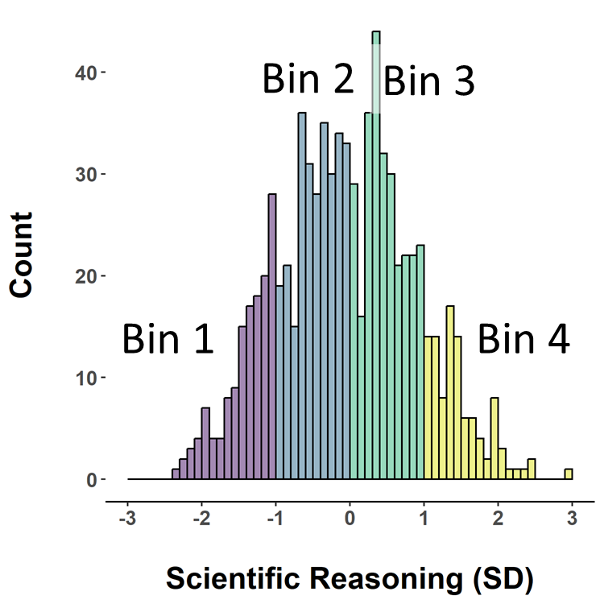

**Figure 1.** Scientific reasoning test scores for 799 students tested in BIOB 170 during the fall semesters of 2020, 2021, and 2022. Scores have been binned for subsequent analysis.

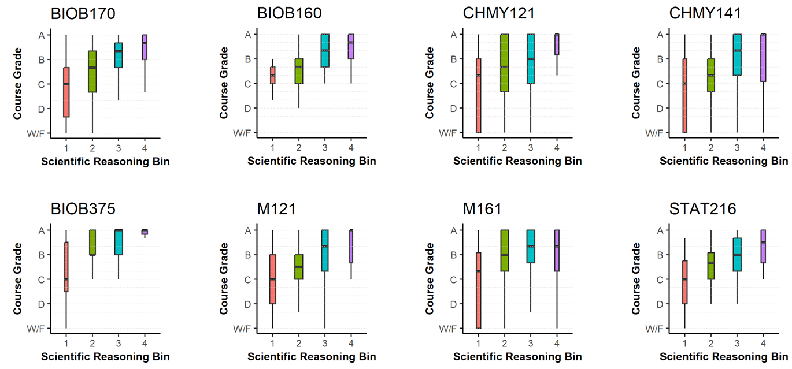

**Figure 2.** Course grades in eight selected STEM courses for students with four levels of scientific reasoning.

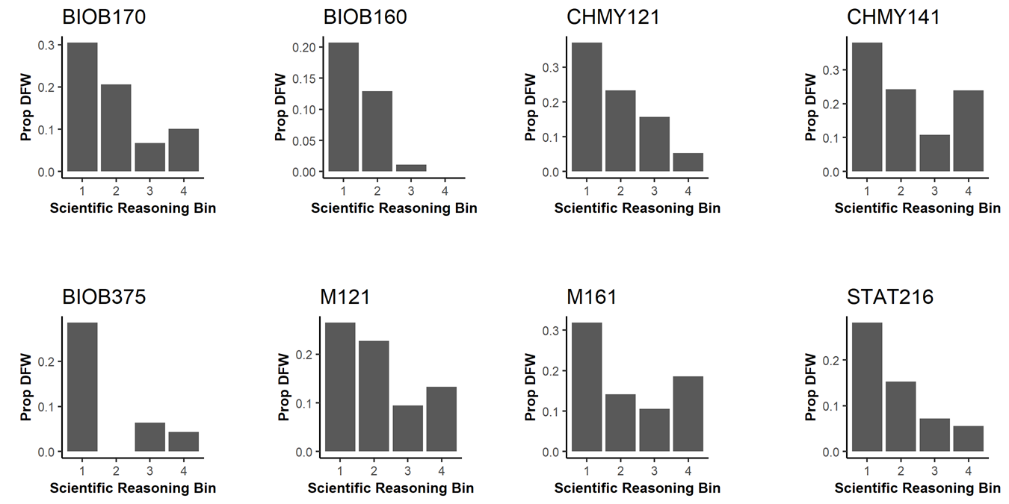

**Figure 3.** DFW rates in eight STEM courses for students with four levels of scientific reasoning.



**Figure 4**. STEM retention rates (with 95% confidence intervals) for BIOB 170 students classified by their scientific reasoning score.

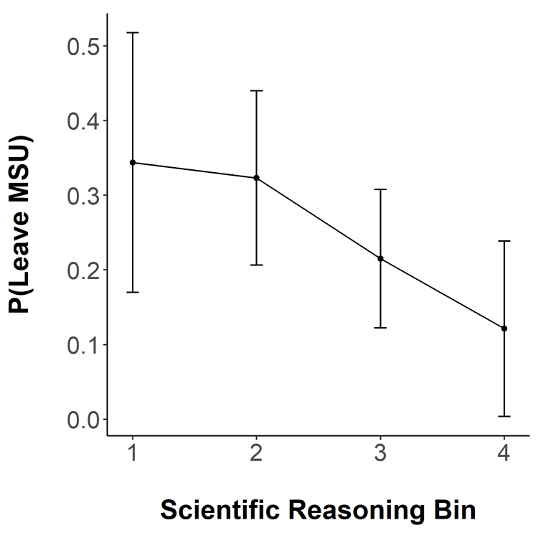

**Figure 5.** The proportion of BIOB 170 students who left MSU without graduating (with 95% confidence intervals) classified by their score on the scientific reasoning test.