The Center for Bilingual and Multicultural Education (CBME) invites you!
We are proud to announce that the CBME will be providing the following programming during the Fall 2019 semester from 11:00-12:00 on Tech Tuesdays and Get-together Thursdays in Reid Hall 418. In addition, we plan to hold our CBME Open House on Thursday, September 19th from 11:00-1:00.
All students are welcome!
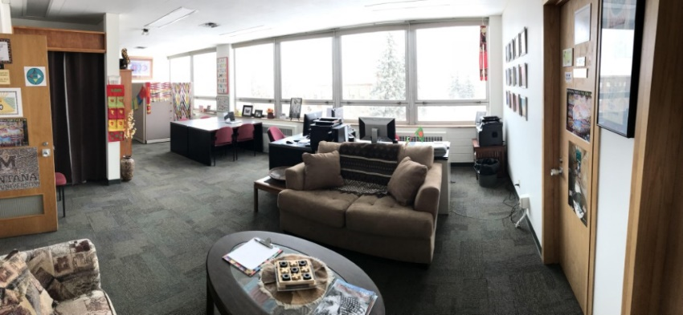
Tech Tuesdays  Date Event  Sept. 17th Flipgrid  Oct. 1st QR Codes  Oct. 15th Dudgeons and Dragons  In the classroom  Oct. 29th Chatterbox  Nov. 5th Keyboard Shortcuts  Nov. 19th Digital Storytelling/Editing Part 1  Nov. 26th Digital Storytelling/Editing Part 2 | Get-Together Thursdays  Date Event  Sept. 12th BINGO  Sept. 26th Indians 101  Oct. 10th MSU Trivia  Oct. 24th IEFA Professional Development  Nov. 14th Foldables

Benefits of Studying at the CBME
- Access to campus computers
- Printing stations
- Kitchen area, great for bringing a lunch
- Large work areas
- Amazing campus view
- Study rewards
- Meeting space for group projects
- Great alternative to the library

For more information contact Dr. Jioanna Carjuzaa at carjuzaa@montana.edu or 994-4941.

