This form is to be signed by every Fergus/Petroleum
4-H Horse Project Member the first year they enroll in a 4-H Horse Project.
If revisions are made to the Policy, it will be redistributed for review and resigning.

I have read all sections of the 4-H Horse Policy Book

________________________ ____________
Members Signature Date

I have read and reviewed the 4-H Horse Policy Book with my child.

________________________ ____________
Parent/Guardian Signature Date

Each 4-H member enrolled in a 4-H Horse Project will receive a copy of the Fergus Petroleum 4-H Horse Policy when they enroll in a 4-H horse project, it must be carefully read and reviewed and kept in the member record book. The sheet verifying this review must be signed by both the member and a parent/guardian and returned to the Extension Office by April 15. This process will be repeated if there are changes made to the policy.
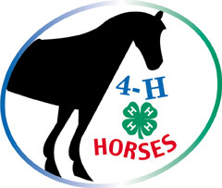
Revised November 2023
Fergus/Petroleum County
4-H Horse Program
Policy
Section 1: Fergus/Petroleum 4-H Horse Committee
Objectives
- To educate youth and adults for living in a global and ever-changing world by using the resources of; MSU Fergus County Extension, the Land Grant University (MSU), and the U.S. Department of Agriculture.
- To encourage 4-H members to learn as much as they can about horses while developing their leadership skills.
- To promote and develop good sportsmanship in all aspects of the program.
The Horse Committee shall;
- Develop and carry out educational programs for members enrolled in horse projects.
- Develop and carry out policy and guidelines for the horse program to function under. Review this policy yearly.
  - Approve all policy developed by horse sub-committees
- Develop an annual budget.
- Preside over the county 4-H Horse Program as deemed necessary.
- Work cooperatively with the 4-H Small Animal and Livestock Committees to coordinate fair activities.
Members of the Committee shall include;
- Enrolled Adult and Teen Leaders from each 4-H Club.
- Enrolled Independent Leaders
- County Agricultural Extension Agent- or a representative from the Extension Office
Horse Leaders
- Work with horse members in their clubs. Keep them informed of upcoming clinics and shows.
- All Fergus/Petroleum County clubs with Horse Members are required to have a representative at every horse committee meeting and at horse show set-up/clean-up.
- Assist club Horse Members with enrollment to make sure they are enrolling appropriately.
- Assist club Horse Members with their Horse Project Records and Workbooks. Make sure they have received all of the appropriate materials from the Extension Office.
- Make sure all club Horse Members and one of their parents have read and reviewed the Fergus Petroleum County 4-H Horse Program Policy and have signed and returned the verification sheet to the Extension Office by April 15.
- Assist club Horse Members with fair enrollment to make sure they entering in the appropriate classes.
- Be familiar with the Fergus Petroleum County 4-H Horse Program Policy.
- Fergus County 4-H program policy will be reviewed each fall and can be changed at a meeting of the Fergus/Petroleum County Horse Committee, held prior to the Leaders’ Council annual meeting (usually mid-November), by a 2/3 vote in favor of the proposed change(s) by those members which are eligible to vote and present at that meeting.
- Assess all Horse Project Members yearly, utilizing the assessment check list in the 4-H Horse Workbooks.

Officers
Chair
- Presides of all Horse Committee meetings
- Works with Extension Staff and Leaders Council
- Calls special meetings as necessary
- Appoints committees to facilitate workings of the Horse Committee
Vice Chair
- Presides over meetings in the absence of the Chair
- Take minutes if the Secretary is absent and sends a copy of those minutes to the Extension Office within one week following the meeting
- Notify’ s leaders of special meetings or workshops
- Notify’ s Extension Office staff and/or Leaders Council of special meetings or workshops.
- Serves as chair of all sub-committee’s
Secretary
- Takes minutes at Horse Committee meetings, e-mail to the Extension Office to be posted to the web site within one week after the meetings.
- Take care of correspondence for the committee
Ag Extension Agent (or Extension Office representative)
- Be a facilitator to the Horse Committee
- Be responsible for getting any complaints received in the Extension Office to the committee in a timely manner.
- Be the liaison between the 4-H Center for Youth Development and the Horse Committee
- Provide guidance and assurance that all activities and project work are in compliance with state and county guidelines.
- Provide guidance and assurance that all committee work is compliant with the values of 4-H Youth Development and that education is the primary objective of all activities.
- Makes sure Central Montana Fair and State 4-H Horse Show results are submitted to the local newspaper.
Voting- to be eligible to vote, committee members must be enrolled in a 4-H Horse Project or be an enrolled 4-H Leader.
Quorum- A quorum will consist of those members present at a Horse Committee Meeting.

Section 2: Policy Rules
Horses
- 4-H Project Horse Ownership. All 4-H Horse Project animals must be owned by the member or in a partnership with their immediate family. Members may also lease a horse if they don’t own their own. The member must be providing the daily care for the horse and the horse must be owned or leased by April 15. A horse carried as a 4-H project may be shown by more than one member of the immediate family in any one year, providing that neither the horse nor the member compete against his or herself. (Must show in different levels and age groups).
- The best experience the Horsemanship and Working Ranch Horse levels will occur when members (Levels 1-7) ride safe, trained horses. Lessons and-or clinics for the rider and the horse, where both participate together, are acceptable in helping members achieve the optimum in the project. All horses carried as 4-H projects and shown in the 4-H Horse Show at the Central Montana Fair, must be in the primary care of the member by April 15. Horses may not be in training with a professional trainer after April 15 of the project year.
- Under extenuating circumstances, such as serious injury or death of a horse, a member may be allowed to switch horses after the April 15th deadline, if that member notifies the Horse Committee as soon as possible, provides appropriate documentation, and submits a formal request to the Horse Committee.
- 4-H members who have advanced to Levels 4-7 and have a horse in training at any time are taking unfair advantage of the 4-H Program.
- Stallions will not be allowed to show in any 4-H horse classes at the Central Montana Fair.
- The Colt to Maturity and Green Horse project horses may not be trained by a professional.
  - If a 4-H member encounters serious problems with their Colt to Maturity or Green Horse project horse, they may seek help from a professional or someone more experienced than themselves as long as the member is present to see how the problem is corrected and consequently learn from the help sessions. The intent is to keep the project safe for the member and to have some logical progression to the project. The emphasis needs to be on safety and learning.
  - If a member has a serious problem that is not being resolved, the member along with his/her parent and/or club leader is encouraged to come to the County 4-H Horse Committee and seek help and guidance in planning an appropriate course of action.
- The same horse can be used in Western and English Horsemanship, Working Ranch Horse, Packing and Driving.
- Colt to Maturity and Green horse projects cannot cross enter in English or Western Horsemanship 1-7 projects. The exception to this rule is that Colt to Maturity 5th year may enter in English or Western Level 7, provided the member has been assessed out of Horsemanship Level 6.
- Colt to Maturity Project Horses are owned as yearlings by the member and are shown and or assessed each year until they are five year olds.
- Green Horse Project Horses. If a member’s horse is un-started (has never been saddled or ridden) the member would enroll in Green Horse Level 1. If a horse has 30 to 90 days of training and has met the assessment criteria of Level 1, the member would enroll in Green Horse Level 2. If the horse had 90 to 150 days of training and has met the criteria of the level 2 assessment, they member would enroll in Green Horse Level 3. If a horse has 150 to 210 days of training and meets the assessment criteria of level 3, the member would enroll in Green Horse Level 4.
- A member may have only one horse per level in the Colt to Maturity and Green Horse program within the same 4-H year.
- A member can request to have the Ranch Horse knowledge test read allowed to them. The test will be proctored by a non-related leader on the day o the competition. The questions may be read aloud but the competitor is responsible for answering the questions on their own.

Section 3 : Enrollment
- Previous year members must have enrollment forms into the office with designated horse projects and project levels by January 1, with no new members being enrolled after April 15. (unless transferring from another club out of county or state). April 15 is the deadline for any additions or corrections to enrollment and project level changes. Independent study project outlines are due April 15. Project outlines and goal sheets should be brought to the fair for the class and interview.
- Members must be enrolled in or completed Level 3 Horsemanship or Ranch Horse Level 3 to enroll in Driving or Packing.
- Members must register separately for English and Western Horsemanship levels on their enrollment forms.
- A member must be 12 year old or older, by October 1 of the current 4-H year, and enrolled in or completed Horsemanship or Ranch Horse Level 3 to enroll in the Colt to Maturity.
- A member must be 12 years old or older, by October 1 of the current 4-H, and enrolled in or completed Horsemanship 3 or Ranch Horse Level 3 to enroll in Green Horse. The horse used in the Green Horse project cannot be a Colt to Maturity Horse or a Horsemanship or Ranch Horse Level 1-7 Project.
- Hunter Hack and Rodeo can be Horse Independent Study Projects (meaning members do not need to be enrolled in Horsemanship/Ranch Horse to participate), but these must be written on the members yearly 4-H Enrollment Form and an Independent Study Outline turned into the Extension Office by April 15. Only members that are in Level 3 or higher in Horsemanship or Ranch Horse may enroll in these projects independently. See Section 7 for more information. To show at State 4-H Horse Show in speed events, the horse must also be shown in another project class and the member must be enrolled in the appropriate project. Note: members may show also show in these events without an Independent Study designation if they are enrolled in a Horsemanship/Ranch Horse project.
- Trail and Bareback are not projects. All horse project members may enter trail and bareback on their fair entry forms. All juniors (10 and younger) must wear a helmet when competing in these events at the fair. See Section 8 form more information.
- Horsemanship Project members may enroll in both Western and English projects, but can only be separated by one level. i.e. Western Horsemanship 3 and English Horsemanship 2.
- A member may repeat any level of Horsemanship or Working Ranch Horse. Once a member has earned two blue ribbons in any one level the member must move on to the next level. If a member wishes to remain in a level after earning two blue ribbons in that level, a written request must be given to the Horse Committee prior to April 15.
  - To stimulate continued personal growth, members enrolled in the horsemanship or working ranch horse project, must move up to the next level after winning first place in their current county level if there are 3 or more contestants in that level or placing 1st at the State 4-H Horse Show. This does not apply to members who are already competing at the highest level possible for their project.
- A member may exhibit only one horse in English Horsemanship, one horse in Western Horsemanship and one horse in Working Ranch Horse.
- Members that enter any classes that require a lope may not enter any Walk/Trot Classes.

Section 4: Competition
Montana State 4-H Horse Show
Central Montana Fair
- No Central Montana Fair judge may give any clinics in Fergus/Petroleum County 6 month prior to the fair in which they will judge.
- At the Central Montana Fair, the Danish system of judging will be used for all 4-H classes. The number of medallions to be awarded in each class is based on class size.
- If a member is unable to show their horse project at the fair and wish to continue the progression through the levels of Horsemanship, Working Ranch Horse, Colt to Maturity or Green Horse, the member needs to contact the Extension Office so a proper assessment can be completed prior to continuation in the project.
- The dress code for Fergus County Shows will be the same as those stated in the Central Montana Fair premium book. Traditional English attire including an English shirt, English breeches, jacket, boots, and a helmet will be worn in Hunter Hack and English classes.
- All juniors (10 and younger) must wear a helmet when competing in bareback and trail classes at the fair. All members must wear a helmet when competing in speed events.
- Any member enrolled any horse-project is eligible to enter showmanship at fair. (With the exception of Horseless Horse, Horse Judging, Horse Careers and Horse Showing). The member must show their own project horse shown at the fair and the horse must be shown in another class.
- Any horse, regardless of age or class, may be excused from the show ring by the judge or show officials if the horse’s behavior is a threat to other horses or riders.
- Within the Colt to Maturity and Green Horse project, a member may enter both English and Western in the 2 year old through 5 year old classes.
- Within the 2 year old project (Colt to Maturity Level 2) loping is a required gait according to the project manual. Two-year olds will walk, trot and lope on the rail only, a pattern will not be required at the Central Montana Fair. (**both rail work and a pattern will be required at State 4-H Show)
  - Green Horse Level 1 may be required to ride a pattern at the Central Montana Fair and will be judged separately from the Colt to Maturity 2 year olds.
  - All Green Horse Projects must be asses by at least 2 4-H Horse Committee Members prior to April 15 to determine what level they will be showing at the fair.
State 4-H Horse Show
- The Central Montana Fair is a qualifying show for the State 4-H Horse Show for Fergus/Petroleum 4-H Members.
  - An injured or sick horse may be given special consideration to qualify for the State Show at a show other than the Central Montana Fair upon receipt of a letter from the parents and the veterinarian explaining the injury. This must be done before the State Show entry deadline. The Horse Committee and/or the County Extension Agent will make the necessary arrangements to follow up on the letter.
  - An injured or sick 4-H member may be given special consideration to qualify for the State Show at a show other than the Central Montana Fair upon receipt of a letter from the parents and the attending physician explaining the injury or sickness. This must be done before the State Show entry deadline. The Horse Committee and/or the County Extension Agent will make the necessary arrangement to follow up on the letter.
Section 5: Tack and Gear
The primary considerations with this section are the safety issues for the exhibitors.
In addition to the specific project manuals and project guide sheets, “Montana Horsemanship Project Manual” is a good resource about tack and gear for Montana 4-H horse projects.
The following are local rules and guidelines adopted by the Fergus Petroleum 4-H Horse Committee which govern 4-H horse classes at the Central Montana Fair. To prepare properly, members should also follow these same rules and guidelines as the train and practice for the fair.
- Snaffle Bits. An acceptable snaffle bit would be considered a conventional 2-ring. Egg Butt, or D-ring with a broken mouthpiece (2 or 3 pieces) with no leverage or gag action. Rings are no smaller than 2 _ or larger than 4_ in diameter. Mouth piece is of smooth material, round or oval in shape, no wire bits or wire wrapped bits. Conchos or other decorative shapes in the center of the rings that can be utilized to change the leverage are not allowed.
- Horses five years old or younger may be ridden with a snaffle bit or bosal and two hands.
- Level 1 riders may ride 1 or 2 handed in a shank bit. This is only allowed at our county level and is NOT allowed at State 4-H Horse Show.
- Running Martingales. Running martingales are allowed in the Level 2 Green Horse and Colt to Maturity classes because the martingales are training aids. For safety reasons, they are allowed only with acceptable snaffle bits. They are not allowed in the horsemanship classes. Standing martingales are not allowed in any 4-H classes except for the speed event classes- barrels and poles.
- Unless it is a green horse in an established Green Horse Class or Horsemanship Level 1, horses older than five years old must be ridden with a curb bit and one-handed. These exceptions will not be allowed at the State 4-H Horse Show. Curb bits are those with a shank, maximum shank length is that which is consistent with Major breed show rule books.
- Curb straps must lie flat and be at least 1 inch wide. Wire or wire-wrapped curb straps are not allowed.
- Tie downs, draw reins, and single reins (roping/barrel) and mechanical hackamores are not allowed. The exception to this is in the speed event classes (barrels and poles) where tie downs and roping reins are common and generally acceptable.
- For the English classes, acceptable headgear is defined as; an English snaffle, Kimberwick, pelham and/or full double bridle. Cavasson nosebands are generally standard equipment.
- Australian stock saddles are acceptable for the classes specified as “Western”.
- Chains, if part of a halter lead strap it cannot go over the nose.
- In addition to the legal bits listed at the end of this document, gag action, life saver, and 3-piece bits are also allowed in the Speed Events division. This is only a local rule. These bits are currently prohibited at the State 4-H Horse Show.

Section 6: Horse Project Assessment
It is the consensus of the Fergus Petroleum 4-H Horse committee that –project assessments be done at the local club level, by a 4-H Horse Leader. If, however, a club needs help with a particular project assessment, the horse committee and the Extension Office would work together to provide the necessary assistance.
Assessments related to fair entries and fair classes need to be completed by April 15. Members would show in their highest, assessed level at the fair. Along with riding and safety skills with each level, the appropriate section of the workbook must also be finished to be assessed up to the next level.
Project assessments will happen in each level of; Horsemanship, Working Ranch Horse, Green Horse, Packing and Driving. Advancement in levels in Horseless Horse Projects, Horse Judging, and Horse Careers are determined by the completion of the workbook requirements- members create displays for fair entry and interview with these projects. The Colt to Maturity Projects advances year to year according to the Colts age. – If a colt is sick or injured, or other difficulties arise in training, the member and colt may be assessed to change to the appropriate level in the Green Horse Project.
Assessment should be an educational experience. The member should feel good about themselves, the project, their horse and the assessment process. This process is a time to build positive self-concept and help the member with decision making and the development of a responsible attitude.
Here are few guidelines to be utilized.
- Member’s project books should be reviewed at assessment. They must have the work done for one level before they can move up to the next.
- The Assessment Check List at the end of each level should be utilized for the assessment.
- All members must start in Level 1 Horsemanship or Ranch Horse. They may be assessed before April 15 (project drop add deadline) and moved up to Level 2 if they are older and their skills and their horse allow.
- Safety is the most important consideration with assessments. Both the members and the horses ability should match the project level. Members in Horsemanship and Ranch Horse should be riding gentle well broke horses.
- Please notify the Extension Office if you assess a member and change their project level before April 15. They must enter the fair according to their project enrollment on April 15.
- 4-H Leaders assessing 4-H Horse members must be familiar with all of the Fergus Petroleum 4-H Horse Policy Book and the 4-H Projects.

Section 7: Classes for Independent Projects Offered by Fergus/Petroleum County
Hunter Hack Class for Members enrolled in Horse Independent Study- Hunter Hack
Members must be enrolled in Horse Independent Study- Hunter Hack and turn in an outline by April 15. Members must be enrolled in or have completed Level 3 Horsemanship to take this project.
To be shown at a walk, trot and canter, both ways of the ring and to jump two fences set at 2’ to 2’6”. Light contact with the horse’s mouth is required. Horses should be obedient, alert, responsive and move freely. Horses may be asked to hand gallop one way of the ring.
Suitable hunt attire shall be worn for show, including coat, breeches or jodhpurs, high English boots or Jodhpur shoes. A safety helmet is required for any jumping and pleasure classes. Ties, chokers, or hunting stocks are required.
Regulation English, snaffle (no shank), Pelham (2 reins), Kimberwicke, Weymouth, and full bridles shall be acceptable. Saddles of English hunting or forward seat type.
Optional; gloves, unrowelled spurs, English breastplate, braiding mane and/or tail –but mane and tail must be the same.
Prohibited; Running or standing martingales, tie downs, draw reins, dropped nosebands.
Project Skills
- Rail workt
- Back up horse
- Light contact with horses mouth
- Hand gallop
- Stand quietly on free rein
- Free movement and manners
- Style over fence (horse and rider)
- Even hunting pace
- Jumping fences without interrupting rhythm
- Jumping at center of fence
- Demonstrate ability to jump fenses 2’ to 2’6” in height
- Use Cavaletties for correct stride
Speed Event Classes for Members Enrolled in 4-H Horse Independent Study- Rodeo
To enroll in this project you must have completed Horsemanship Level 3 or Ranch Horse Level 3.
The intent of offering this Independent Study Project is to allow Fergus/Petroleum County 4-H Members the option to only enter Speed Event Classes at the Fair, or enter a Horse in Speed Events that they do not have entered in another class at the Central Montana Fair. **Please note- this option does not apply to the Montana State Horse Show, at State Show you must ride a horse in speed events that is also shown in a level class.
Placing in Barrels and Poles will be based on time. The judge may elect to place the class on form and horsemanship due to safety and arena conditions.
Per Montana 4-H rules, all members competing in speed events are required to wear a helmet, regardless of age.
Please carefully review Section 5: Tack and Gear.
Section 8: Supplemental Classes offered for Horse Project Members
Trail Classes
Eligibility
- Five classes will be offered, enter by 4-H age as of Oct. 1 of current 4-H year. Juniors- 10 and younger, Intermediates- 11 to 13, Seniors 14 and older. Yearling trail and Green Horse/Colt to Maturity Classes will also be offered. Horses ridden in trail must be shown by that member in another 4-H Horse Project class.
- Junior members (10 and younger) must wear a helmet during competition in this class.
- Western hat or riding helmet, boots, and long sleeved white shirt. Chaps and spurs are optional.
- In all classes the judge will ask all contestants to perform individually.
- This class will be judged on the performance of the horse in maneuvering the obstacles. The horse should work with reasonable loose rein without undue restraint. The judge will have the right to ask for rail work.
- Obstacles will be used from and approved list. The distance between obstacles shall be at the discretion of the judge.
Mandatory Obstacles
If the horse hesitates at any obstacle, the rider will be flagged on to the next obstacle, at the discretion of the judge, and will lose points for that obstacle.
- Opening, passing through and closing gate. (Use a gate which will not endanger horse or rider, gate constructed with minimum of 50 inches from the top of the gate to the ground and a minimum width of 4 feet).
- Ride over a wooden bridge. (Bridge should be of sturdy construction with a minimum width of 36 inches and with a non-slip ramp approach).
- Back through elevated or un-elevated poles or cones. Poles/cones will be at least 36 inches apart.
Optional Obstacles
- Ride over at least 4 logs.
- Water hazard.
- Side pass.
- Box- obstacle consisting of four logs or rails each 5 to 6 feet long, laid in a square. Each contestant will enter the square by stepping over the log or rail at the designated side. When all four feet are inside the square the rider will execute a 360 degree turn (right or left), pause and depart by stepping over the log or rail opposite side of entry.
- Cattle work in Ranch Horse Trail.
Prohibited Obstacles
No bales of hay or straw or tires will be used in a trail class.
No obstacles that require dragging are to be used.
No live animals other than cattle.

General
While a horse is in motion, riders’ hands shall be clear of horse to avoid cuing. Horse to be penalized by an unnecessary delay while approaching obstacles.
Judges are encourage to advance on to the next obstacle when any horse is taking excessive time at an obstacle, or if horse has 3 refusals the rider will be asked to move on and receive a 0 for that maneuver.

Yearling Trail
Requirements include those for the Trail Class, except maneuvers will be accomplished by leading the yearling through course rather than riding. There are no member age breakdowns for this class, exhibitors must be enrolled in Colt to Maturity Level 1, Yearling.
Bareback Equitation Classes
Eligibility
- Three classes will be offered, enter by 4-H age as of Oct. 1 of current 4-H year. Juniors- 10 and younger, Intermediates- 11 to 13, Seniors 14 and older.
- Junior members (10 and younger) must wear a helmet during competition in this class.
- Horses ridden in bareback must be shown by that member in another 4-H Horse Project class.
Equipment
- Western or English type equipment may be used, all show in the same class. Head gear shall be either a bosal hackamore or a grazing snaffle, curb, half breed, bar, spade bit, pelhams, Weymouth, and/or full bridles. Chain curb is permissible, but must meet the approval of the judge, must be at least one-half inch in width, and lie flat against the jaw of the horse.
- No saddle or bareback pads may be used.
- No chaps, spurs, whips, crops or other devices will be allowed.
Instructions to Riders
The class will enter the ring and proceed in a counter-clock-wise direction. The class will be worked at walk, jog trot and lope, in both directions of the ring. Backing or work individually may be required by the judge to assess the extent of the riders’ horsemanship skills.
The rider is judged in this class on his ability to ride and control a horse without the use of a saddle. A riders hall be judged on his basic position; hand, leg, seat and back. A rider should sit in a balanced relaxed manner, up close to the horse’s withers, keeping the back straight, shoulders even, and an arch in the small of the riders back. A rider should keep his arms in close to his body.
Western Riders
Rein hand (one finger between the reins is permissible) should be held loose and should be positioned directly above and in front of where the saddle horn would be if a rider was using a saddle. The position of the rider’s free hand is optional but should indicate a relaxed, not sloppy, balanced attitude of the body and should be kept free of the horse. If shown in a ring snaffle bit, two hands may be used on the reins. The legs maintain contact with the horse- giving necessary leg grip. The foot is turned out just slightly and the heels should be level of or slightly lowered close to the horse just behind the horse’s elbows. A rider should be able to sit in the trot bareback. No posting at the trot will be permitted. An imaginary straight line drawn from the riders shoulder or hop should drop at the back of the heel and straight line from the knee should drop in front of the toe. A rider in this class must be able to display, through his riding ability in the ring, his knowledge of how to handle a horse properly. A rider is penalized if he changes hands on the horse. While the horse is in motion, the rider’s hands shall be clear of the horse. A rider falling off is not an automatic disqualification, but the judge may dismiss a rider if they are concerned for their safety.
English Riders
Hands should be over and in front of the horse’s wither, knuckles thirty degrees inside the vertical, hands slightly apart and making a straight line from the horse’s mouth to riders elbow, holding of the reins optional. Eyes up and shoulder back, toes slightly out and ankles flexed in, heels down, calf of leg in contact with horse and slightly behind girth.
At the walk and slow trot, rider’s body position should be vertical; posting trot, inclined forward. At the canter, body position is halfway between that for the posting trot and walk.
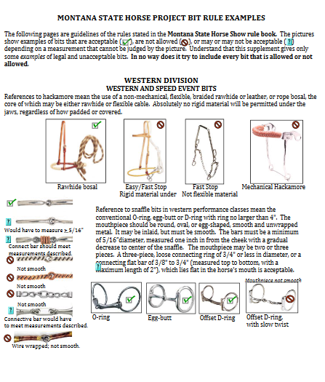
Central Montana Fair Horse Project Bit Rule Examples
(modified from the State 4-H Horse Show Rules)

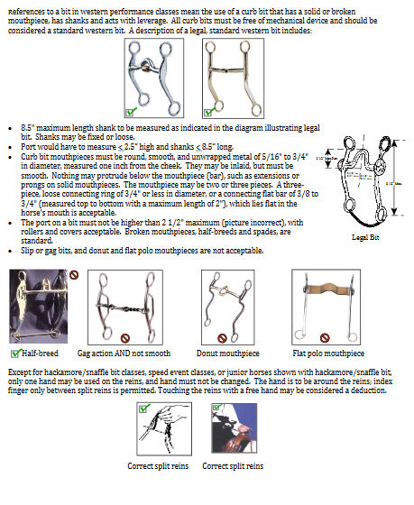
Note:
Gag action and donut/lifesaver bits are permitted during the speed events at the Central Montana Fair, but are prohibited at the State 4-H Horse Show
Flat polo mouthpieces are not acceptable.

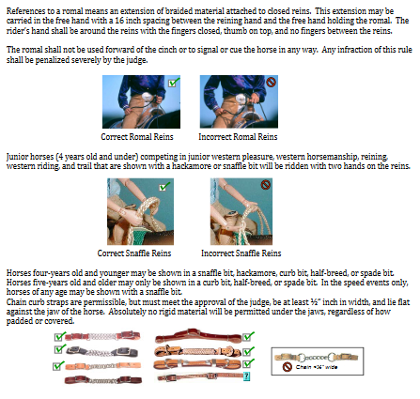

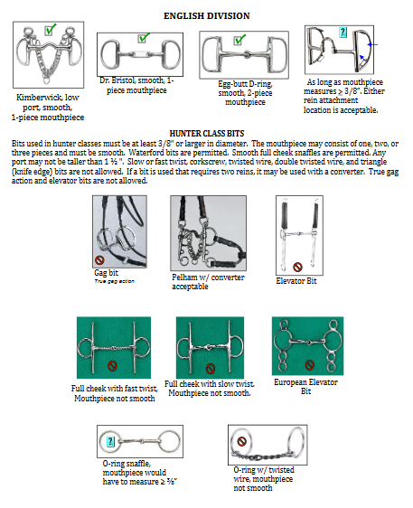
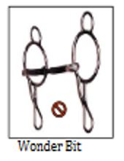
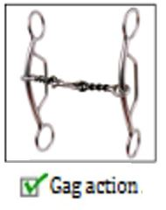
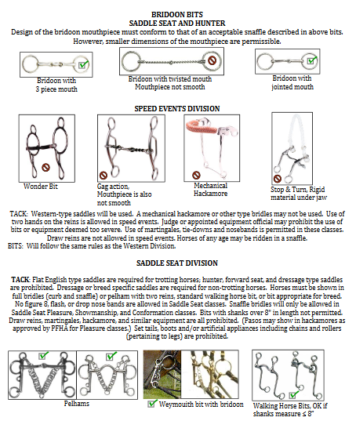
Note: Gag action and donut/lifesaver bits are permitted during the speed events at the Central Montana Fair, but are prohibited at the State 4-H Horse Show

