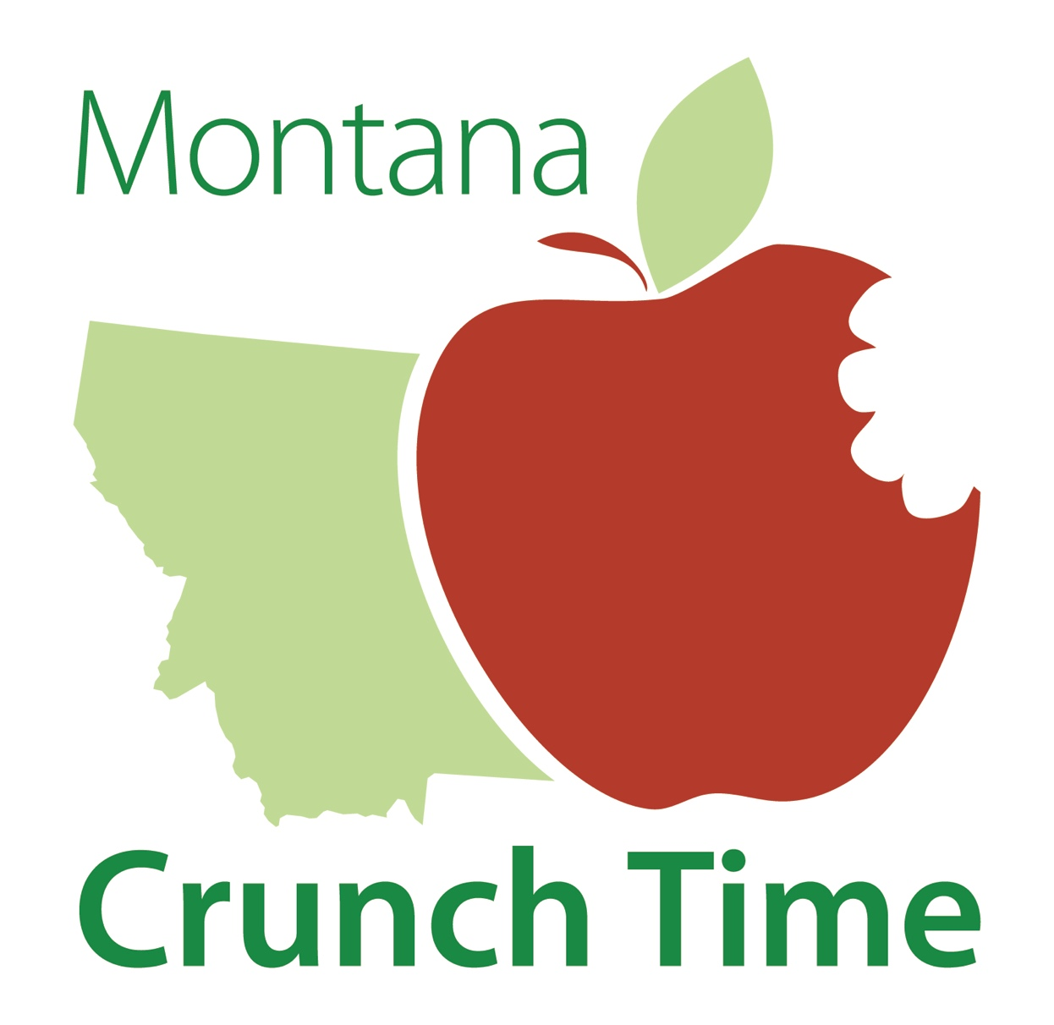

Join preschools, schools, colleges, and individuals across Montana in celebrating National Farm to School Month by crunching into any locally grown or raised food on

October 19th

For more information about Montana Crunch Time, to register and receive your guide, visit:

**montana.edu/  
mtfarmtoschool**

Share your “crunch byte”(video and photos) on social media with

#MTCrunchTime

Montana Crunch Time is sponsored by the Montana Farm to School Leadership Team and partners. Learn more about the Montana Farm to School Leadership Team and the member organizations at: www.montana.edu/mtfarmtoschool/leadership-team/index.html

Scan here to get crunching!