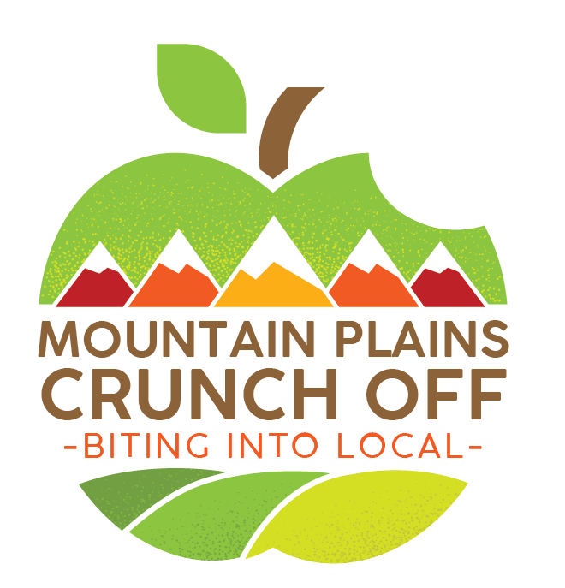

**October 2022 Crunch Off  
Toolkit**

**Colorado, Kansas, Missouri, Montana, Nebraska,**

**North Dakota, South Dakota, Wyoming**

**Guide Contents**

**What is the Mountain Plains Crunch Off? 3**

**Steps to Get Started 3**

**How Can I Find Local Products? 4**

**Tips for Success 4**

**Crunching During Covid…………………………………………………………………………….5**

**Resources 6**

**Learning Activities for Middle and High School 6**

**Learning Activities for Pre-K and Elementary School 6**

**Press Release Template 7**

**Social Media Post Template 7**

**Other Ideas for Creating a Great Crunch Event……………………………..8**

**Sample Photo Release (for any pictures taken)…………………………….9**

**Recipes 10**

**Suggested Reading 10**

**Contact Information 11**

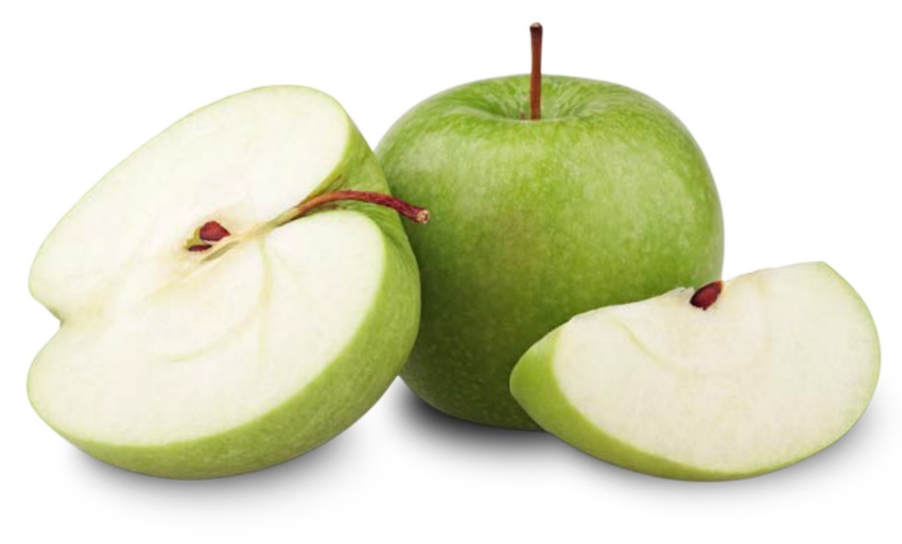

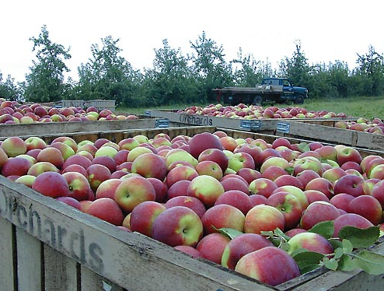**What is the Mountain Plains Crunch Off?**

In celebration of Farm to School Month, States throughout the Mountain Plains Region (CO, MT, MO, KS, NE, ND, SD, WY) are competing to see which State can get the most “crunches” into a local apple, or other locally-grown produce, per capita. Each State is designing its own event with its respective dates and times; please refer to State-specific resources provided upon your registration, for more details.

As a Crunch Off participant, you will join students, teachers, farmers, parents, community members, and local food enthusiasts in celebrating the wonderful produce the Mountain Plains Region has to offer. Your Crunch efforts will encourage healthy eating and support local agriculture while celebrating Farm to School Month and shedding light on the wonderful efforts of our school food service partners.

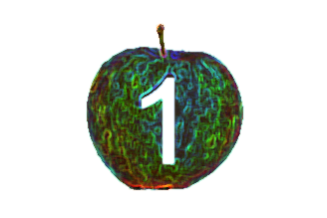**Steps to Get Started**

**Register!** If you would like to host a Crunch event, register your event here: <https://ksde.sjc1.qualtrics.com/jfe/form/SV_d9VPRUhjrVr5ppc> You must register to be counted!

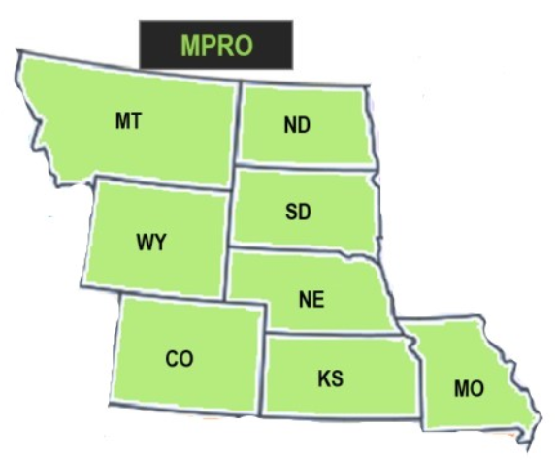**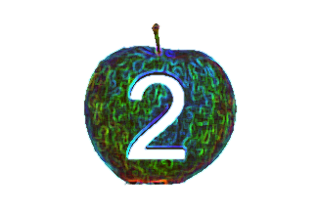Create a Crunch Team!** Find a group of individuals who are excited about Farm to School and local food. Consider including students, teachers, food service staff, administrators, the PTA, and community members to help you plan and promote your event.

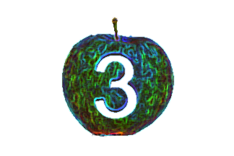**Decide what you will crunch and where you will get it from!** Please note each State has its own rules on what items count as “crunchable,” so if you would like to crunch something other than an apple, please refer to the State-specific resources provided upon registration, or reach out to the point of contact in your State, found at the end of this guide.

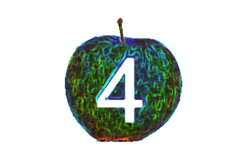**Create your Crunch plan!** You may choose to have a school-wide Crunch in a large assembly, individual classrooms, during breakfast or lunch, with individuals at different locations all at the same time, or at some other time and place. Each State has its own rules (and guidance concerning Covid-19) on where and when Crunches can take place; please refer to the State-specific resources provided upon registration.

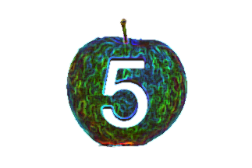**Promote your Crunch event!** Share your event on social media, print media, school announcements, newsletters, etc. There are template press releases and social media posts at the end of this guide for your use.

**How Can I Find Local Products?**

* Look for local apples and produce via DoD Fresh, when applicable. DoD Fresh allows school districts to use their entitlement dollars to purchase fresh produce. See the [How to Utilize DoD Fresh to Purchase Local Produce](https://www.fns.usda.gov/f2s/using-dod-fresh-buy-local) fact sheet for more information.
* Ask your distributor if they carry local apples or other local produce.
* Source apples and produce from a food hub.
* Find a local farmer or farmer’s market.

**Tips for Success**

1. **Get as many people involved as you can!** Once you have decided on where your Crunch will take place, start to spread the word! Get students, parents, food service staff, teachers, administrators and community members excited about your Crunch through social media, newsletters, press releases, PTA announcements and any other way you typically interact with the community.
2. **Be conscious of waste!** For younger audiences, consider using apple slices or halves to reduce the amount of delicious local food that is wasted.
3. **Consider incorporating lessons!** Consider incorporating lessons on farming, soil, the water cycle, photosynthesis, or other relevant topics into the curriculum during the week or day of the Crunch. At schools, local produce can also be incorporated into the Fresh Fruit and Vegetable Program (FFVP), and the FFVP can serve as the Crunch event! All of this can help get students excited about trying local produce and get them interested in continuing to try local food at the conclusion of the event. There are sample learning activities below, in this guide, for your use.
4. **Consider a field trip!** Farm field trips are a great way to help students get excited about local produce, learn more about the food system, and have a successful Crunch! If a field trip isn’t feasible, consider inviting farmers to school to speak at an assembly or conduct lessons in classrooms.
5. **Determine how much you plan to spend!** Remember that if you are spending less than the applicable micropurchase threshold, you do not need to obtain quotes to purchase your apples. If you are spending an amount between your small purchase and micropurchase thresholds, small purchase rules apply (obtain three quotes, and document them).
6. **Share your success!** Consider inviting local media or have a point person to capture the event to share on social media and other outlets.
7. **Be a great communicator!** Communicate early and clearly about when your Crunch is taking place, how people can participate, and why you are crunching.

**Crunching During Covid**

If your community isn’t ripe for large gatherings of people this year, consider the following alternatives!

* Encourage kids/parents to crunch at home. Help them find local apples/produce and send home worksheets that they can complete.
* Consider a Zoom, Google Hangouts/Meet, or other technology platform for everyone to crunch together virtually, in a socially distanced manner; if possible, build this into kids’ learning time.
* Encourage the submission and compilation of selfies, of everyone crunching simultaneously but separately.
* Use hashtags – such as #MountainPlainsCrunch -- to post and collect images from social media.
* Promote crunches in the classroom or in other small groups as allowed.

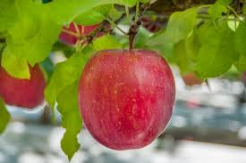

**Sample Announcement to Families for Remote Crunches**

Dear Families,

This year _________ (school/center/organization) will be participating in the Apple Crunch on ____ (date). Given the challenges imposed by Covid-19, this year’s will be a __________ (virtual/individual) Crunch.

We encourage you to review the sample lessons/complete the sample activities we have sent home. At ____ (time), all children are encouraged to crunch into their apple (or other local produce). Please send a picture of this crunch to us at _______ (contact information).

**OR**

At _____ (time) please have your child log into the his/her class’s _____________ (technology platform name) and have his/her apple ready. We will all conduct our Apple Crunch together as a group, virtually.

Sincerely,

___________ (Name)

**Resources**

**Crunch Time Activities**

* 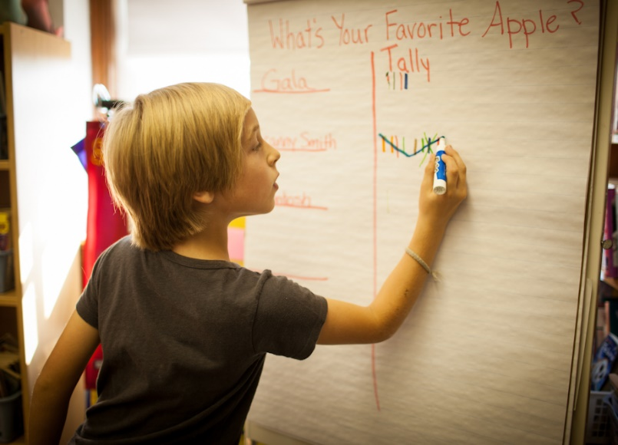Conduct taste tests with apple (or other produce) varieties.
* Host a cooking contest, class, or demo for apple recipes.
* Set up an apple themed photo booth for the Crunch event.
* Read apple themed books (see suggested reading list at the end of this guide).
* Ask students to describe verbally or in writing how an apple looks, feels, tastes, and smells.
* Ask students to write a story about an apple or reflect on the field trip to an orchard/farm.
* Ask students to count the seeds in an apple.
* Ask students to weigh and measure the circumference of an apple.
* Discuss the life cycle of an apple, how it grows, and photosynthesis.
* Put apple slices into cups with different liquids (water, soda, vinegar) and ask students to hypothesize what will happen in each experiment. Observe for a week and reflect on each hypothesis.

**Learning Activities for Middle and High School**

* [Apple Cider Lesson](https://edibleschoolyard.org/resource/apple-cider%20) from Edible School Yard
* [Food Miles Lesson](http://sustainableschoolsproject.org/curricula/food-miles-lesson%20) from Sustainable Schools Project
* [Youth Leadership Curriculum](http://www.iatp.org/documents/farm-to-school-youth-leadership-curriculum-all-lessons-and-worksheets%20) from Institute for Ag and Trade Policy
* [Nourish for Life Curriculum](https://www.nourishlife.org/teach/curriculum/) from Center for Ecoliteracy

**Learning Activities for Pre-K and Elementary School**

* [Preschool Apple Activities](https://theeducatorsspinonit.com/apple-theme-social-studies-lessons/,%20) from The Educators’ Spin on It
* [25 Apple Themed Activities for Preschool](https://www.pre-kpages.com/25-apple-activities-for-preschool/,%20) from Pre-K Pages
* [Farm Field Trip Guide](https://cpb-us-east-1-juc1ugur1qwqqqo4.stackpathdns.com/blogs.cornell.edu/dist/0/4074/files/2014/06/GMFTS-Farm-Field-Trip-Guide-20121-2jpsrpd.pdf) from Green Mountain Farm to School (VT)
* [Apples, Apples, Apples Lesson Plan](https://www.scholastic.com/teachers/lesson-plans/teaching-content/apples-apples-apples-lesson-plan/) from Scholastic

**Other Ideas for Creating a Great Crunch Event**

* Tie the event to FFVP – also a great way to fund the Crunch Off
* Look for strategic partnerships – Head Start, State Government, FFA, FCS/Home Economics/Ag Economics classes, Snap Ed Regional Leads, CACFP providers, WIC programs, Senior Farmers Markets, local farmers markets, Extension offices, etc.
* Have promotional materials at SNA conference, CACFP trainings, NSLP trainings, etc.
* Translate materials into Spanish or other relevant languages to your state/community
* Work with local grocery stores/producers to promote the Crunch Off and point folks to locally grown produce

**Press Release Template**

{NAME}

{SCHOOL/ORGANIZATION}

{PHONE}

{EMAIL}

{DATE}

{School/Organization} is joining schools, preschools, nonprofits and local food enthusiasts in celebrating Farm to School Month by competing in a nine-State Crunch Off competition! {State} is competing against {all other states} to determine who will be crowned the Mountain Plains Region Crunch Champion through having the most crunches into local apples or produce per capita.

{Include specifics on your event and how to be involved}

This Crunch event encourages healthy eating, supports local agriculture and helps students and community members gain a deeper understanding of the food system. {Include details on activities you are doing for the Crunch}

Help {State} win the Crunch crown by joining our Crunch event! For more information, or to participate in the Crunch, please contact {contact name} at {phone} or {email}.

**Social Media Post Templates**

* Did you know there are 2,500 varieties of apples are grown in the United States? Bite into your favorite local apple on {ENTER CRUNCH DATE} to be a part of the {ENTER ORGANIZATION/SCHOOL NAME} Crunch!
* Did you know one apple has five grams of fiber? Fiber is a healthy part of all diets and can help reduce blood sugar swings, lower cholesterol, and keep you full. Crunch into this healthy snack on {ENTER CRUNCH DATE}.
* Did you know apples are a member of the rose family? Crunch into this beautiful fruit on {ENTER CRUNCH DATE}.
* Utilize these hashtags: #MountainPlainsCrunch, #FarmToSchool, #F2S(StateName)

**Sample Photo Release (for any pictures taken)**

School/Other Entity Name

CONSENT/RELEASE FORM

I consent to the sale, reproduction, and use, royalty-free, of motion picture films, video, recorded sounds, and still photography of me by the Entity Name for all purposes including, but not limited to, education, training, trade, display, editorial, advertising, promotion, art and exhibits.

In giving this consent, I release the Entity Name, its officers, employees, nominees, and designees from liability for any violation of any personal proprietary right I may have in connection with such sale, reproduction, and use.

I am more than 21 years of age.

Signature & Date

Address

City State Zip Code

Consent of Guardian

Minor Name ____________________________________

I am the parent and/or guardian of the minor named above, and have the legal authority to execute consent and release. I approve the foregoing and waive any rights to the above.

Signature & Date

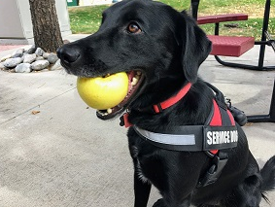**Recipes**

* [Baked Apples](http://www.montana.edu/mtfarmtoschool/documents/Warm%20Baked%20Apples%20with%20Dried%20Cherries%20and%20Raisins%20_%20ChopChop.pdf)
* [Apple and Cheddar Whole Wheat Quesadilla](https://www.wholefoodsmarket.com/recipe/apple-and-cheddar-whole-wheat-quesadillas)
* [Apple Pie Smoothie](https://www.allrecipes.com/recipe/174319/apple-pie-smoothie/)
* [Apple Cake](http://www.montana.edu/mtfarmtoschool/documents/AppleCake_MTRecipeRoundup.pdf)
* [Apple Sauce](https://www.food.com/recipe/quick-homemade-applesauce-no-sugar-added-201473)

**Suggested Reading**

|  |  |
| --- | --- |
| [A Tree is a Plant](https://www.amazon.com/Tree-Plant-Lets-Read-Find-Out-Science/dp/0062382101) by Clyde Robert Bulla | [Apples](https://www.amazon.com/Apples-Gail-Gibbons/dp/0823416690) by Gail Gibbons |
| [The Seasons of Arnold’s Apple Tree](https://www.amazon.com/Seasons-Arnolds-Apple-Tree/dp/0152712453)  by Gail Gibbons | [Applesauce Day](https://www.amazon.com/Applesauce-Day-Lisa-Amstutz/dp/0807503924) by Lisa Amstutz |
| [How to Make an Apple Pie and See the World](https://www.amazon.com/Make-Apple-World-Dragonfly-Books/dp/0679880836) by Marjorie Priceman | [Bring Me Some Apples and I’ll Make You a Pie: A Story About Edna Lewis](https://www.amazon.com/Bring-Some-Apples-Ill-Make/dp/0544809017) by Robbin Gourley |
| [How Do Apples Grow?](https://www.amazon.com/How-Apples-Grow-Betsy-Maestro/dp/0064451178) by Betsy Maestro | [Apples, Apples, Apples](https://www.amazon.com/Apples-Nancy-Elizabeth-Wallace/dp/0761451811) by Nancy Elizabeth Wallace |
| [The Apple Pie Tree](https://www.amazon.com/Apple-Pie-Tree-Zoe-Hall/dp/0590623834/ref=sr_1_1?dchild=1&keywords=the+apple+pie+tree+zoe+hall&qid=1624976855&sr=8-1) by Zoe Hall | [I Am an Apple](https://www.amazon.com/Apple-Hello-Reader-Science-Level/dp/0590372238/ref=sr_1_1?dchild=1&keywords=i+am+an+apple&qid=1624976941&sr=8-1) by Jean Marzollo |
| [Johnny Appleseed](https://www.amazon.com/Johnny-Appleseed-Steven-Kellogg/dp/0688064175/ref=sr_1_2?dchild=1&keywords=johnny+appleseed+kellogg&qid=1624976754&sr=8-2) by Steven Kellogg | [Apples, Apples Everywhere!](https://www.amazon.com/Apples-Everywhere-Learning-Harvests-Autumn/dp/1404863885/ref=sr_1_8?dchild=1&keywords=apple+book+kids&qid=1624977034&sr=8-8) by Robin Koontz |

**Contact information**

**Colorado**: Britt Martens: [Brittany.martens@state.co.us](mailto:Brittany.martens@state.co.us); Erin Opgenorth: [opgenorth_e@cde.state.co.us](mailto:opgenorth_e@cde.state.co.us); McKenna Pullen: [pullen_m@cde.state.co.us](mailto:pullen_m@cde.state.co.us)

**Kansas**: Barb Depew: bdepew@ksde.org

**Missouri**: Lexi Jose: [alexis.jose@mda.mo.gov](mailto:alexis.jose@mda.mo.gov); Lisa Lauer: [Lisa.Lauer@health.mo.gov](mailto:Lisa.Lauer@health.mo.gov)

**Montana**: Aubree Roth: [aubree.roth@montana.edu](mailto:aubree.roth@montana.edu)

**Nebraska**: Sarah Smith: [sarah.e.smith@nebraska.gov](mailto:sarah.e.smith@nebraska.gov); Marla Kurtenback: [marla.kurtenbach@nebraska.gov](mailto:marla.kurtenbach@nebraska.gov)

**North Dakota**: Deb Egeland: [degeland@nd.gov](mailto:degeland@nd.gov); Kara Haff: [khaff@nd.gov](mailto:khaff@nd.gov)

**South Dakota**: Cynda Frey: [cynda.frey@state.sd.us](mailto:cynda.frey@state.sd.us); Anna Barr: [anna.barr@sdstate.edu](mailto:anna.barr@sdstate.edu)

**Wyoming**: Carla Bankes: [Carla.Bankes@wyo.gov](mailto:Carla.Bankes@wyo.gov)

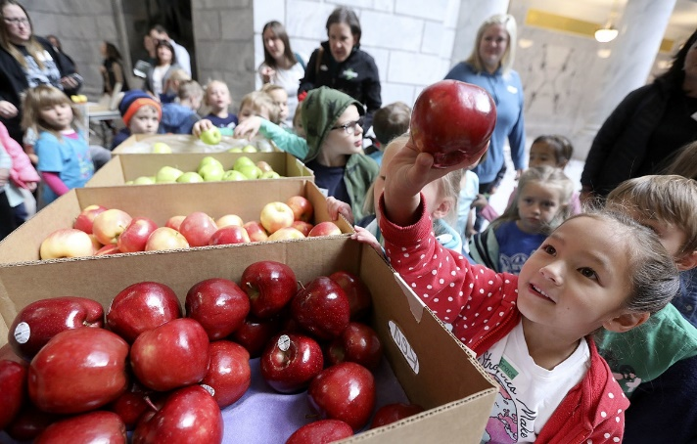

*In accordance with Federal civil rights law and U.S. Department of Agriculture (USDA) civil rights regulations and policies, the USDA, its Agencies, offices, and*

*employees, and institutions participating in or administering USDA programs are prohibited from discriminating based on race, color, national origin, sex,*

*disability, age, or reprisal or retaliation for prior civil rights activity in any*

*program or activity conducted or funded by USDA.*

*Persons with disabilities who require alternative means of communication for*

*program information (e.g. Braille, large print, audiotape, American Sign*

*Language, etc.), should contact the Agency (State or local) where they applied for benefits. Individuals who are deaf, hard of hearing or have speech disabilities*

*may contact USDA through the Federal Relay Service at (800) 877-8339.*

*Additionally, program information may be made available in languages other*

*than English.*

*To file a program complaint of discrimination, complete the* [*USDA Program Discrimination Complaint Form*](http://www.ocio.usda.gov/sites/default/files/docs/2012/Complain_combined_6_8_12.pdf)*, (AD-3027) found online at:* [*http://www.ascr.usda.gov/complaint_filing_cust.html*](http://www.ascr.usda.gov/complaint_filing_cust.html)*, and at any USDA office, or*

*write a letter addressed to USDA and provide in the letter all of the information requested in the form. To request a copy of the complaint form, call (866) 632-*

*9992. Submit your completed form or letter to USDA by:*

*(1) mail: U.S. Department of Agriculture*

*Office of the Assistant Secretary for Civil Rights*

*1400 Independence Avenue, SW*

*Washington, D.C. 20250-9410;*

*(2) fax: (202) 690-7442; or*

*(3) email: program.intake@usda.gov.*

*This institution is an equal opportunity provider.*