**2025 *SUMMER INTERNSHIP* Program**

# MTP2 Intern Program Overview

# Each year, the MTP2 intern program hires and places highly qualified students with businesses across the state of Montana to develop industry-tailored solutions for energy, water and waste challenges for manufacturing businesses. This page will provide more information about eligibility, the hiring process, training and orientation, technical assistance, and guidance for the final projects and case studies. If interested in this program, please [view our links](https://www.montana.edu/pollution-prevention/summerinternship/caseStudies.html) to past projects for additional insight into the program.

# MTP2 Eligibility Requirements

To qualify for the MTP2 intern program, you should be a junior, senior, or graduate student and should possess good oral and written communication skills. A technical academic background may be required, but requirements will vary from project to project. Troubleshooting, independent work, and leadership skills are required. Typical majors of past MTP2 interns are Chemical/Mechanical/ Environmental Engineering, Sustainable Food and Bioenergy Systems and Environmental Science/Studies to name a few. Although not required, interns are encouraged to seek academic credit for this internship. MTP2 does not pay tuition or fees for academic credit. **Students may be enrolled at any accredited university to apply.**

# MTP2 Hiring Process

# \****Applications for the Internship will be accepted year round until all project spots are filled.***\*

When developing the intern program each year, MTP2 solicits Montana businesses to host interns. This process takes place from October to March. Students are encouraged to apply from November-April. Once the businesses have been confirmed, student applications are evaluated to determine which students are the best fit for the program. From there, applicants are notified if they have been selected for an interview. Candidate interviews will be scheduled with MTP2 faculty starting in February with selections being made by late April. Once an offer is made, the student will have two weeks to commit to the 9-week internship, which includes the following timeline.

# **MTP2 Internship Timeline**

* + Week 1: Training/Orientation, Monday, June 2nd through Friday, June 6th, 2023 (35 hours).
  + Week 2 through Week 9: Monday, June 9th through Thursday, 31st (35hrs/week)
  + Week 9: Interns final presentations Friday, Aug. 1st.

The MTP2 training and orientation is designed to teach interns about pollution prevention, lean manufacturing and value stream mapping and receive the tools necessary to apply their knowledge to individual internships.

# Technical Guidance

# The intern and their business are supported by a technical advisor from Montana Manufacturing Extension Center (MMEC). Additionally, the business provides an internal, onsite advisor for the intern. The MMEC advisor guides the intern by assisting in the initial Value Stream Mapping process, discussing reduction ideas, offering resource leads, keeping the project on track and coaching on how to gather the necessary data to evaluate the business and present findings. Additionally, MTP2 and/or the student’s academic advisor will review progress bi-weekly.

# Deliverables

Interns must prepare a written case study of their findings as well as a final presentation. These reports outline the intern’s recommendations for the business, provide a cost analysis of the potential savings, and provide next steps for the business to pursue the proposed solutions. The intern will present their findings in a detailed presentation to the MTP2 faculty, advisors, and intern peers on the last week of their internship. The final presentation will be used for future projects and shared with other interested MTP2 candidates. Additionally, interns may be asked to share short presentations during future intern trainings.

# Confidentiality

MTP2 fully respects a business’s need to protect its sensitive, proprietary, and confidential information. We work with the intern to ensure adherence to our Confidentiality Statement and address any concerns regarding confidentiality.

# Pay

Undergraduate interns will receive $19/hr. Graduate interns will receive $21/hr. Interns are responsible for their own housing; however, some scholarships are available to help interns not placed with Bozeman businesses.

### [**Click here**](https://www.montana.edu/pollution-prevention/summerinternship/P2_Internship_program.html) **(**[**www.mtp2.org**](http://www.mtp2.org)**) to apply to the MTP2 internship. For questions, please contact:**

JENNY GROSSENBACHER, *DIRECTOR, MTP2*  
 *406-994-4292* * [*jenniferg@montana.edu*](mailto:jenniferg@montana.edu)

***“Empowering businesses to be part of the solution, not the pollution.”***

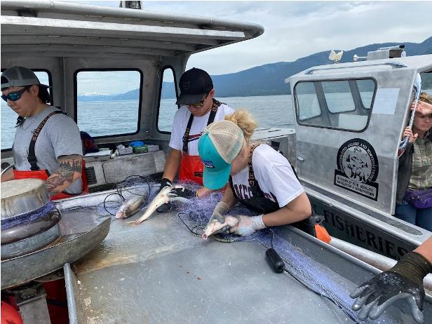  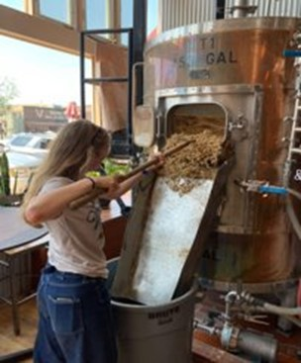

**2022 intern, Elissa Ikola, working with Native Fish Keepers, Inc. (left),**

**and 2024 intern, Jess Rahn, working with Philipsburg Brewing.**