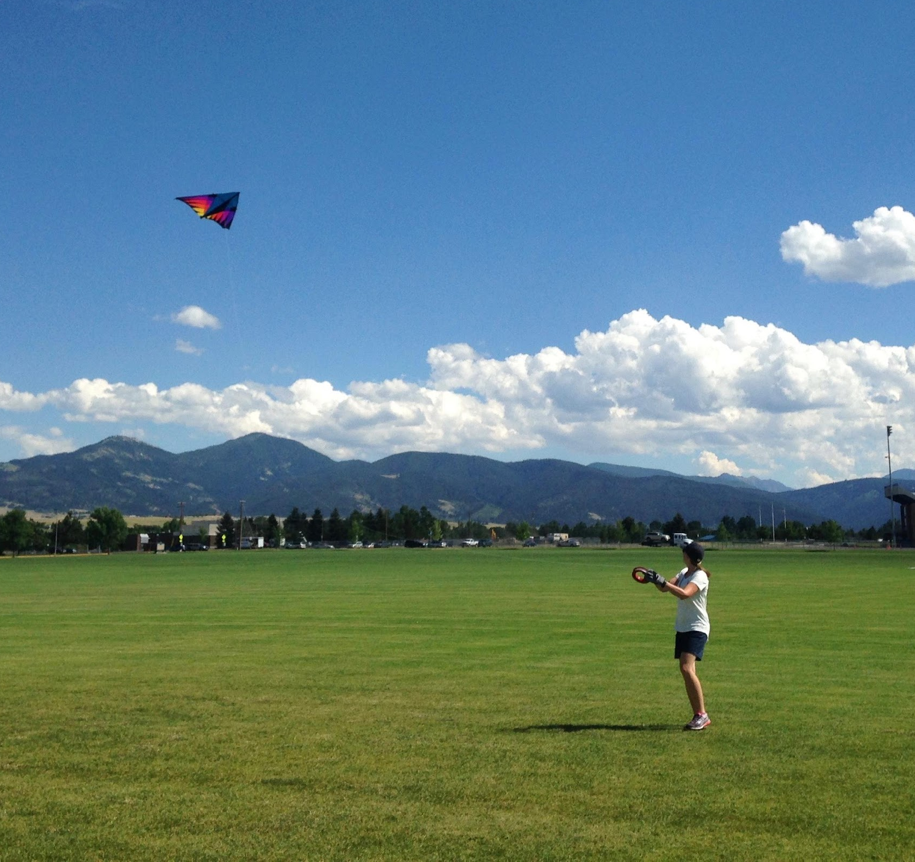
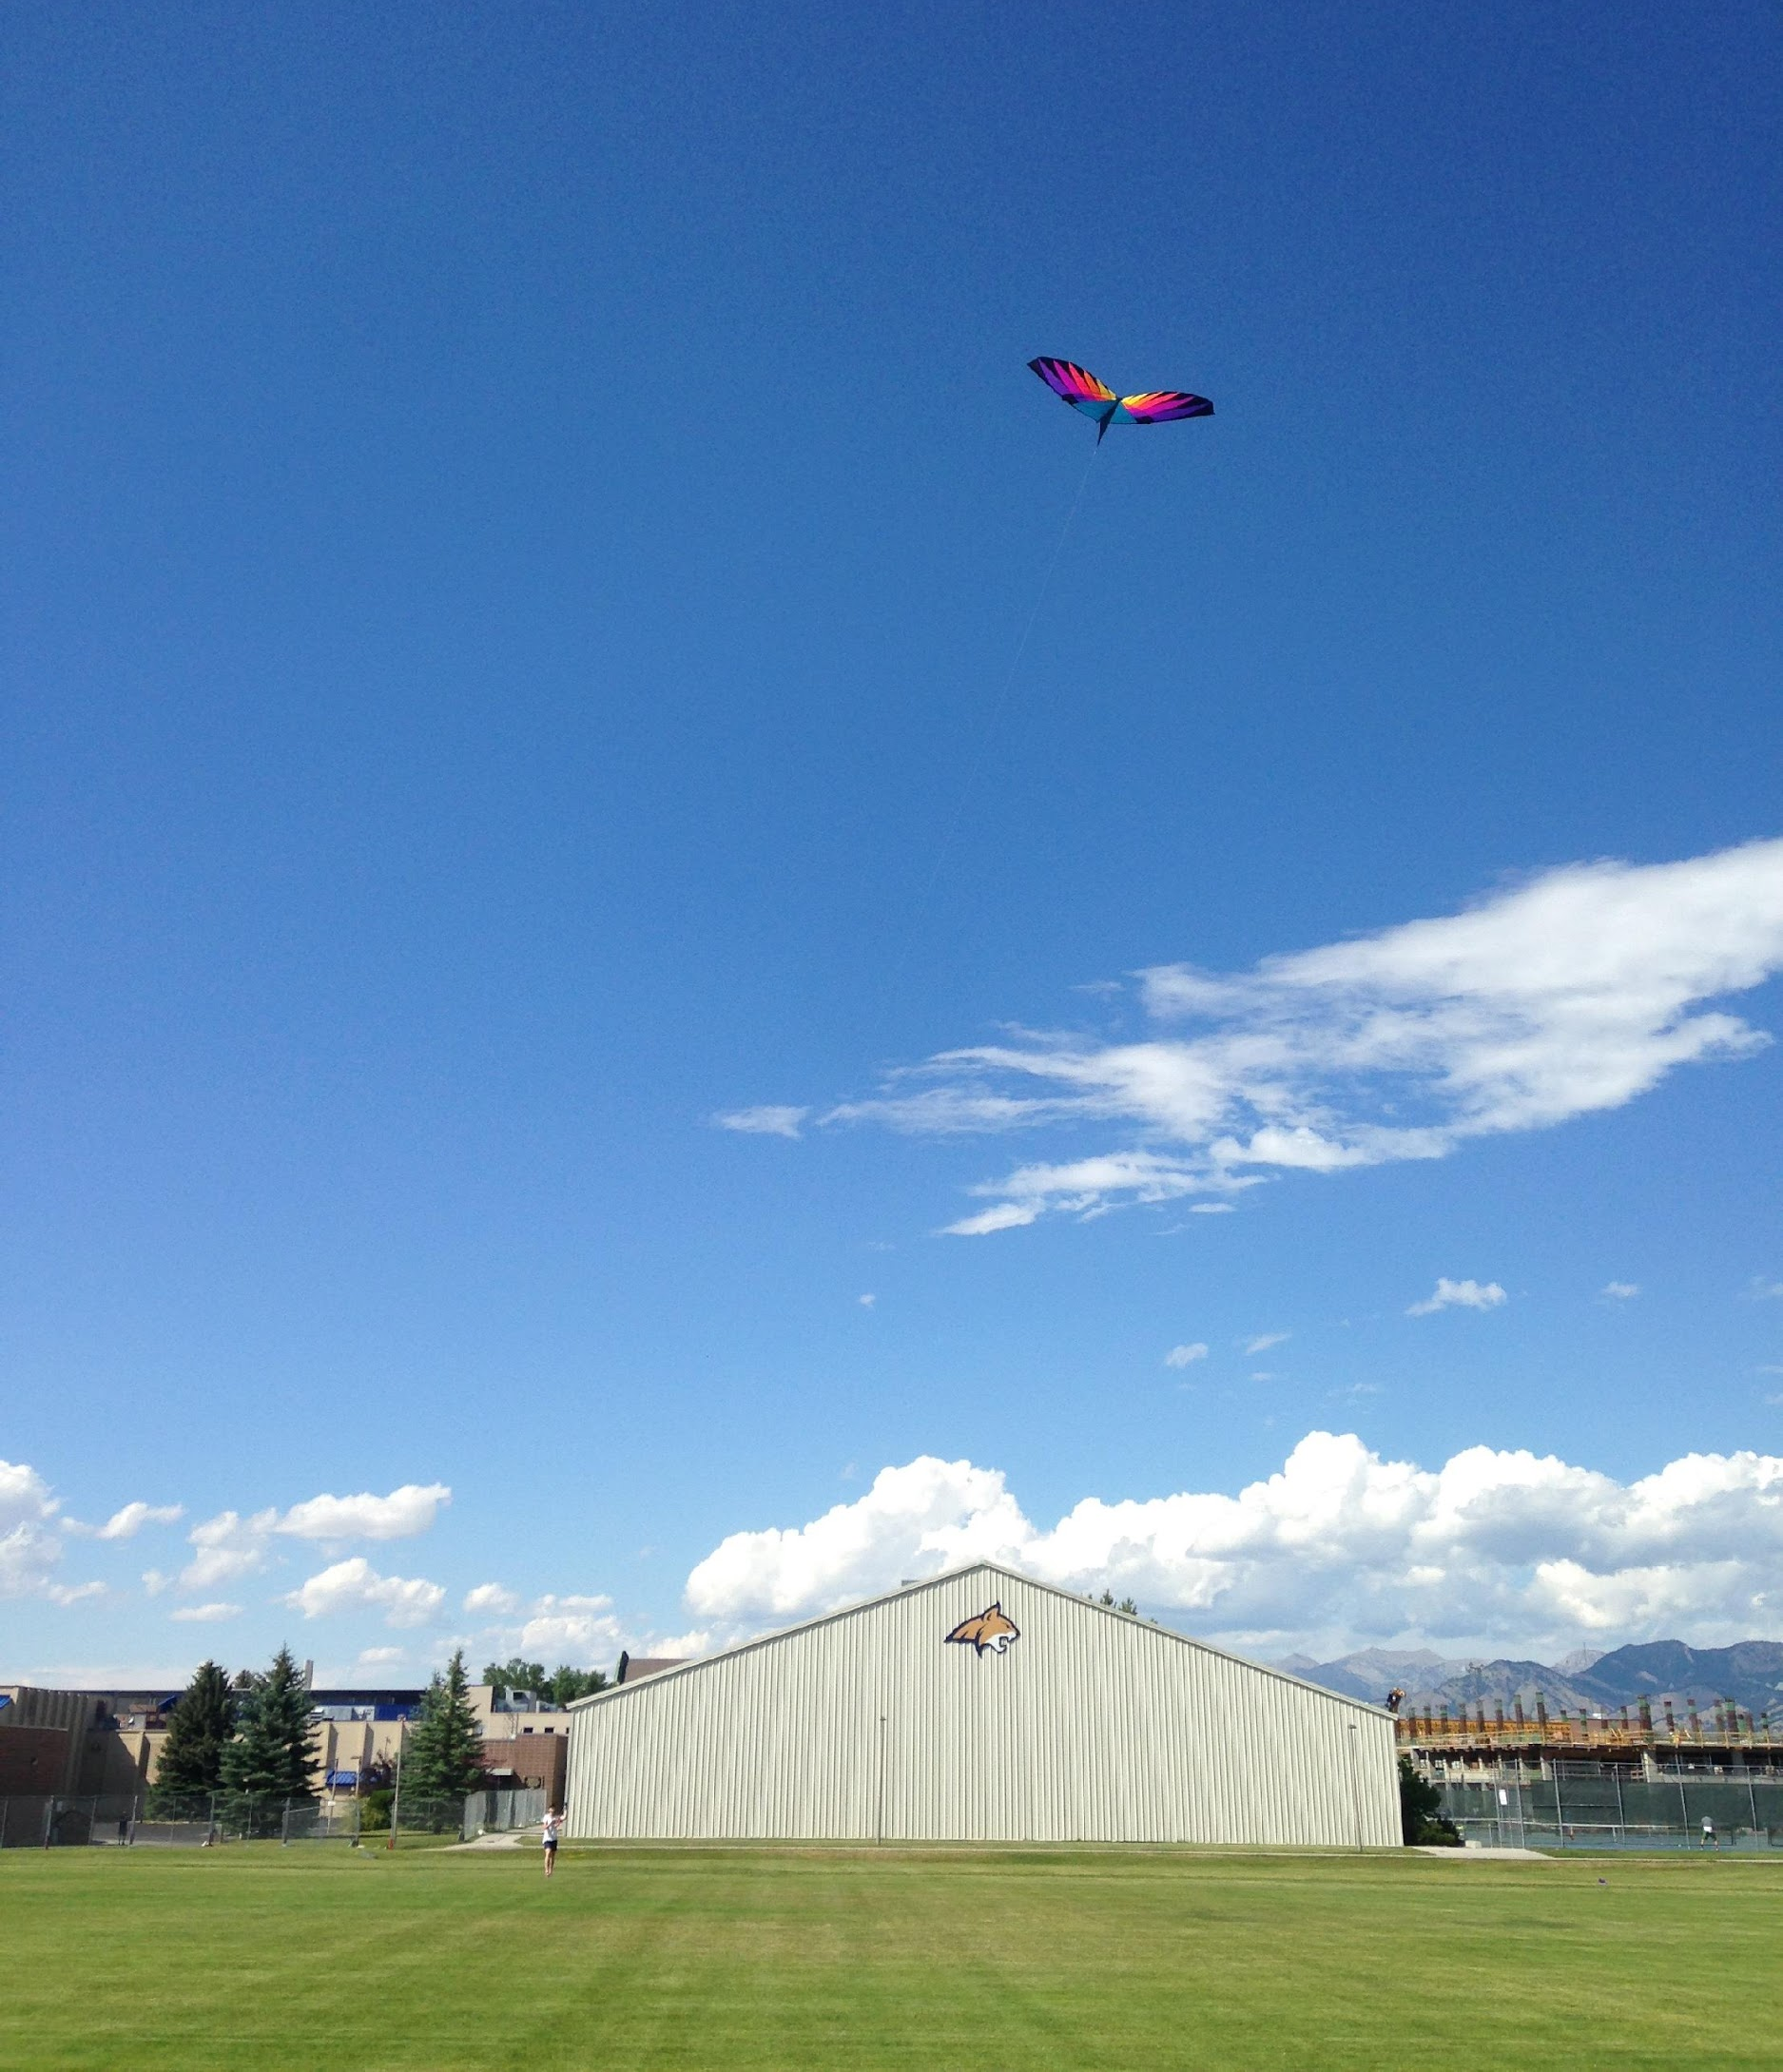
Flight report: First attempt at flying kites at MSU
By Suzi Taylor. Flight date: July 28, 2016
MSU practice fields near 7th and Kagy. N 45°39.771, W 111° 2.861 Team members – Suzi, Ann, Sarah H, Connie, Jamie
Equipment
- 7 ft Levitation Delta
- 9 ft Levitation Delta
- Alpine DC
- Pocket anemometer
- Aerokats mission field equipment checklist
- Atmosphere Investigation integrated 1-day data sheet (time, temp, elevation, lat/long, pressure, humidity, clouds)
- Gloves, lightning striker, pen. Wish we had clipboard! Should stick first aid kit and sunscreen in the bag.
- Sent How to Fly A Kite packet for team ahead of time
We flew three different kites in the late afternoon on Thursday, July 28. No aeropods or instruments. Fairly light wind conditions (about 4-8mph), but the winds were variable. We used the Atmosphere Investigation data sheet.
Team took slightly longer than I expected to assemble the kites. There were some hang-ups with the short spars vs. long spars; this might be something we help our brand-new teachers with. We especially had some trouble packing up the big kite; I wish we had taken photos, as it was unpacked so it would have been easier to put back together. My colleagues were not as deliberate and patient as I hoped they would be; I imagine this would be even tougher with kids.
The Alpine DC seemed the easiest to get up and to keep aloft, though all of them went up pretty easily. It took two people to get the 9 ft kite aloft. Because the winds were variable, we found ourselves backing up and shifting around in the field, eventually finding ourselves potentially too close to the edge.
The team was impressed with the power of the kites. Nobody had ever flown a kite that large. When the winds shifted and it looked like the kite might come down, it was actually a little bit scary. They appreciated the gloves and understood why we did the safety briefing. They really appreciated that I brought ball caps for visibility (I kept them in the equipment bag). I would like to check out the lightning striker when there is actually lightning in the area.
Toward the end, Sarah’s husband and small children drove by and stopped. The kids came running out toward the kite, and we had to be careful that they didn’t get too close or run into the string. Also, two students came walking across the field while we were flying and basically passed right under the kite, almost under the string. Since the winds were shifting, we were worried that the kite might actually come down on them.

