Principles and Practices for Student Location Data
Published November 6, 2024 (proposed)
The MSU Student Location Policy (https://www.montana.edu/policy/student-location) necessarily defines student location for purposes of student notification requirements for professional licensure programs and waiving of particular student fees for students studying at a distance. This document is meant to record our practices for future reference.

Table of Contents
100.00 Professional Licensure Programs
200.00 Students Studying at a Distance
300.00 Included Zip Codes and Exclusion Zone Map

100.00 Professional Licensure Programs
All students, prospective and enrolled, must be notified if their intended or declared major program does or does not meet the State educational requirements for licensure in the State of the Student Location.

110.00 Prospective Students in Professional Licensure Programs
Disclosures are required for all programs leading to professional licensure or certification to prospective students identifying if the institution does or does not meet State educational requirements where the student is located before enrolling in the program.
On an on-going basis, the Undergraduate Admissions Office and Graduate School will make an individual written disclosure to prospective students as to if their intended program does or does not meet the educational requirements for initial licensure/certification in the state of the student’s location.

120.00 Enrolled Students in Professional Licensure Programs
At the beginning of a student’s first term of enrollment in a Professional Licensure Program, the Office of the Registrar will make an individual written disclosure to students enrolled in Professional Licensure Programs as to if the program does or does not meet the educational requirements for initial licensure/certification in the state of the student’s location.
It is the professional licensure program faculty and staff’s responsibility to keep state authorization lists up to date at least annually and notify the Office of the Registrar if the status in an individual state changes. The Office of the Registrar provides an individual disclosure to enrolled students if the institution determines that the curriculum no longer meets educational requirements for licensure where the student is located; the disclosure must occur within 14 days of the university making that determination.

200.00 Students Studying at a Distance
Students studying at a distance are automatically eligible for waiver of the athletic fee, health service fee, recreation fee, and student government/activity fee. Students studying at a distance may pay any or all of these fees to access these activities if they choose. New students’ location will be set on census day of their first term.
Zip code areas that are not eligible for the fee waiver. Zip code areas not on this list are eligible for the fee waiver. See map below for the exclusion zone.

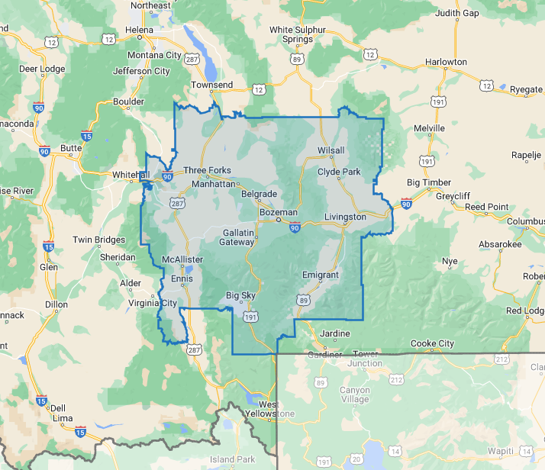
300.00 Included Zip Codes and Exclusion Zone Map
59715 | Bozeman
59717 | Bozeman
59718 | Bozeman
59719 | Bozeman
59771 | Bozeman
59772 | Bozeman
59730 | Gallatin Gateway
59714 | Belgrade
59741 | Manhattan
59047 | Livingston
59752 | Three Forks
59745 | Norris
59760 | Willow Creek
59086 | Wilsall
59716 | Big Sky
59740 | McAllister
59065 | Pray
59735 | Harrison
59018 | Clyde Park
59027 | Emigrant
59747 | Pony
59729 | Ennis
59721 | Cardwell
59643 | Toston

